In 2021, I got a call from a psychiatric textbook editor asking me to cowrite a new chapter on recovery, and to make it international so it wouldn’t seem like America is the only place developing recovery programs. I protested that although I have a career’s worth of expertise and I’ve travelled a fair bit and met some interesting people and programs while doing trainings around the world, I was hardly a world expert. They thought I was good enough.
I thought I was important to include the voices of people with lived experience and they connected me with Charlene Sunkel who led the Global Mental Health Peer Network from her home in South Africa. She brought both international expertise and a wide variety of voices from her network to the project. Although we never met in person, and there’s a sizeable time zone difference between us, we worked well together.
I’m very proud of this chapter. It’s the most comprehensive and multidimensional piece I’ve ever created, or ever, about recovery. In some ways, this is my “legacy” piece, including much of my previous “greatest hits” placing them within a worldwide context and even highlights the fine work by my dear colleagues in Singapore and the Czech Republic.
It was finally published in 2024, but it’s buried in a $400, 5000-page textbook that literally weighs 30 pounds. I decided to include it in this website too, fearful that otherwise almost no one would see one of my very best works.

The Recovery Model
(2021) by Mark Ragins MD and Charlene Sunkel
Published in Tasman’s Psychiatry, 5th edition, 2024

Introduction:
The recovery movement is very ambitious. It seeks to take us beyond treating illness, to focusing on helping people have better lives, and regain important roles and acceptance within their communities…even for people whose symptoms can’t always be eliminated or controlled and even for people with very serious persistent conditions like schizophrenia. While the mainstream of psychiatry seeks ever more successful illness treatments, the “outsider” movement of recovery seeks ever more successful ways of promoting better lives.
These ambitions have been taken up in many countries at the highest level of policy making. For example, The US President’s New Freedom Commission on Mental Health declared in 2003: “The time has long passed for yet another piecemeal approach to mental health reform. Instead, the Commission recommends a fundamental transformation of the Nation's approach to mental health care. This transformation must ensure that mental health services and supports actively facilitate recovery, and build resilience to face life's challenges.”
How to best achieve better lives depends heavily on the individual country, community, and culture the person lives in – how mental illness is viewed, if at all, and how people recover to be accepted. As a result, recovery model services and programs develop and look very different not only throughout the world, but for people of different cultures, races, and socioeconomic status within any given country.
Many people have seen pieces of the recovery movement that have been added to their community and its services. Maybe there’s a mental health lived experience advocacy group meeting with the government to promote the services they value. Maybe there are psychiatric rehabilitation programs available, like supported housing, education, or employment. Maybe there’s a peer-run wellness center. Maybe there are “dual diagnosis” programs facilitating substance abuse recovery or “trauma sensitive” services. But there’s almost never an entire recovery-based system of care. As a result, most people visualize recovery as an add-on to conventional services, rather than a coherent, comprehensive paradigm that all of us can find a way to participate in.
In order to emphasize the cohesiveness of the recovery model this chapter will focus on several intertwined levels:
- The roots of the recovery movement – people with mental health lived experience (patient/service-user/consumer/survivor, etc.) and other advocacy groups, groups working with people who don’t fit into the system, rehabilitation staff seeking to reintegrate people in the community, and other parallel recovery services like substance abuse and trauma recovery
- The core paradigm shifts of the recovery movement that effectively address the exposed problems and underly the entire model: from illness-centered to person-centered, from professional-driven to client-driven, and from deficit-based to strengths-based
- The shifts in treatment relationships and services provided as we move from a medical model to a rehabilitation model to a recovery model (highlighting the changing role and strategies of psychiatrists)
- Examples of specific recovery-based services that can be used at different stages of illness and recovery that are embracing those three core paradigm shifts (highlighting the contribution of peer provided services)
- Examples of the development of larger, more complete recovery-based programs and systems of care as they organically grow and evolve in very different places and with very different leadership
A note about language: The preferred terminology when referring to people who identify as having personal experience of mental health problems or services vary between contexts and within a specific context, and although this chapter mostly uses the terms “persons with mental health lived experience” and “persons with mental illness” intermittently, it is merely for simplicity of writing and does not mean the exclusion of individuals or groups identified otherwise in this context. We acknowledge that different terms such as service-user, survivor, person with psychosocial disabilities, experts by experience, people with lived experience, consumer, peer, etc. have context-specific meanings and reflect accordingly throughout the chapter.
Part 1: Roots of recovery movement
In a variety of places, for example in New Zealand, recovery advocacy has been intimately tied to deinstitutionalization efforts, “Recovery is the first genuinely post-institutional service philosophy. It has broad origins, but over the last 15 years it has been profoundly shaped by the service user movement. We define recovery as achieving the life we want in the presence or absence of mental distress. The right conditions for recovery are the strength and interrelationships of our self-determination, personal resources, supports, therapies, and our social and economic opportunities.”
In the United States, where much of the recovery movement emerged about 1990, the “outsiders” who coalesced into the recovery movement were shaped by the conditions at the time – widespread deinstitutionalization but then the neglect of community mental health centers and other community supports, the civil rights movement, the dismantling many of the Great Society antipoverty programs including federally subsidized housing, the war on drugs, and overall massive increases in the role of police and incarceration.
Four often overlapping groups are worthy of deeper attention because of their prominence and impact on the direction the recovery movement has taken:
- Mental health advocates, especially the service-user / survivor movement
- Staff who were working with people who did not engage and collaborate well with the standard medical model system – including homeless people, people who abuse substances, people who refuse treatment, incarcerated people, traumatized people, etc.
- Rehabilitation staff who saw people’s lives limited artificially by systematic hopelessness, lack of opportunity and inclusiveness, and prejudice.
- Other recovery programs and staff, especially 12-step substance abuse and trauma recovery

- Mental health advocates, especially the service-user / survivor movement
There is a long and illustrious history of people who have experienced mental illnesses writing and speaking about their experiences and advocating from a position of personal power against injustices and abuses, maltreatment and neglect. Clifford Beers wrote “A Mind That Found Itself” in 1906 after repeated psychiatric hospitalizations for manic-depression that led to substantial advocacy and reform efforts which continue today, over a century later, as Mental Health America. Joanne Greenburg’s “I Never Promised You a Rose Garden” dramatically described her recovery form severe schizophrenia with therapy, in an era of widespread electroshock and lobotomies for these “hopeless” conditions giving hope to millions. Deinstitutionalization and the civil rights movement gave birth to a new emboldened generation of “survivor” advocates, including Judy Chamberlin who wrote “On Our Own: Patient-Controlled Alternatives to the Mental Health System”, a foundational text in the Mad Pride movement.
A set of assertions emerged:
- There is hope for recovery from any mental illness and we are the proof of that.
- Neglect, abuse, and even custodial care, the common results of hopelessness and dehumanization, are intolerable
- People with mental illnesses have valuable contributions to make to their own recoveries and should be empowered and listened to, not locked up, overmedicated, coerced, and have their voices and decisions disregarded and over-ruled.
- Other people’s, including mental health professionals, fear of, prejudices, negative expectations, stigmatization, segregation and exclusion of people with mental illnesses together form substantial barriers to recovery, oftentimes more substantial than the conditions themselves
- People with mental health lived experience often know better what they, and others like them, need to recover and should provide, design, and lead their own “peer-run” service provision
- People with mental illnesses should join together and advocate for themselves, their rights, and the services and opportunities they deserve.
Listen to some voices of lived experience from the Global Mental Health Peer Network (GMHPN) (www.gmhpn.org) developed from the successful initiatives of Movement for Global Mental Health (www.globalmentalhealth.org), an international virtual network of individuals and organisations established in 2018. The focus of its work has involved the building of a sustainable structure to serve two main purposes: to develop a global leadership of lived experience; and to create a sophisticated communication platform where the lived experience community can share their views, opinions, perceptions and experiences. The vision of the GMHPN is the “strengthening the voices of persons with lived experience globally through empowerment and inspiring respect and acknowledgement of their experiences, views and opinions as valued and equal citizens of the world”.
Narrative: Claudia (South Africa)
The workplace was a major source of stress for me for a variety of reasons, namely that there were no reasonable accommodation practices in place and middle-to-senior management did not understand my diagnosis and therefore did not have the tools necessary to help me. I recall printing out information and brochures from our local counselling call centers to share information about my diagnosis with relevant information on what could be done to alleviate some of the stressors at the workplace. I handed this over to management but heard nothing further from it. The incorrect assumption was that once I was discharged from psychiatric hospitalization, therefore my condition was rectified and had gone away. Many mornings I would get out of bed without having slept more than 3 hours, after which I was subjected to long hour traffic rides to work which would make me more anxious so much so that by the time I arrived at work, I was a wreck. I felt hopeless. Helpless. Fatigued. The stress in the workplace poorly affected my health, my personality and my levels of motivation. I was tired of the increased work responsibilities due to organizational restructuring. I merely needed increased social support from my employer and empowerment to improve my overall well-being.
Narrative: Wariimi (Kenya)
The negative aspect that has been least helpful is the stigma associated with mental health. I have received all sorts of comments in this regard, you are not praying enough, depression is from the devil, you are too pretty to have depression, etc. Kenya has only started opening up to having mental health conversations and there is still a long way to go.
Narrative: Sandra (South Africa)
One key factor that has negatively impacted my recovery over the years has been discrimination and stigma. I have had to leave a few jobs because of this. However, I am in a place in my life where I am ‘out’ about my condition to everyone around me and the impact is immeasurable.
Narrative: Alexandra (United Kingdom)
What hindered my recovery the most was the lack of autonomy I had over my own mental health care. I may not have understood that a neurochemical imbalance underpinned my social anxiety when I was first diagnosed at the age of nine, but I was fully aware that I liked ballet, disliked math, and occasionally liked to spend time alone. If a mental health practitioner gave me the choice to choose between art therapy or straight counselling, I could easily have determined which option that would work best for me. Moreover, I —whether knowingly or not—would have gained confidence from having autonomy over the betterment of my own health and wellbeing. Unfortunately, I was never given that choice. My recovery plan was often dictated by therapists and school advisors, and my own ideas of what would work well for me were often dismissed. This lack of autonomy continued well into my teenage years and eroded my already low self-esteem. How could I have the confidence to make my own decision about my health—let alone my life—if even those surrounding me felt my mere suggestions were without merit useless? It was only once I began to collaborate with mental health practitioners to develop a path to recovery that I felt empowered, gained confidence, and made significant strides towards recovery.
Narrative: Victor (Hong Kong)
A key aspect that has been unhelpful in my recovery has been mechanical reactions – the habitual reactions of saying “I understand” or “I am afraid that you cannot do this at this moment” can be very demotivating and overwhelming, especially when I was in bad times.
Moving beyond complaining and protesting, a substantial number of people with serious mental illnesses sought to use their experiences to improve services for everyone, so other people wouldn’t have to go through what they did. Patricia Deegan overcame several years of lying on her grandmother’s couch listening to voices through a “conspiracy of hope” to become a psychologist and the most poetic leader of recovery in the US. She audiotaped numerous people talking about what their recovery was like and what helped them to recover, finding common themes and services, and building recovery tools and services built upon their personal evidence of success. Many recovery services, self-help, peer-provided, and professionally-led have been developed over the last several decades built upon listening to people tell us what works for them.
Focusing on the reality of recovery:
When very successful people tell their stories of recovery from even the most dreaded mental illnesses it’s hard to deny the reality of recovery. The more stories that are shared, the more paths to recovery appear: Dan Fisher is an MD, PhD psychiatrist who recovered from schizophrenia primarily through emotional connection with others and lives well without medications. He describes his path for others as Personal Assistance in Community Existence (PACE). He loudly declares: “People can and do recover from severe emotional distress known as “mental illness”.” Elyn Saks, who wrote of her own dramatic battels with schizophrenia in “The Center Cannot Hold: My Journey Through Madness” recovered with intense psychoanalysis, finally accepting Clozaril, and lots of personal support to become a law professor at USC fighting for the decision-making rights of people with serious mental illnesses.
It’s not easy sharing personal stories like these and becoming an advocate, but sharing lived experiences has the ability to validate the human element of mental health and mental illnesses and gives meaning of the experience for the person telling the story.
Narrative: Nicole (Singapore)
It took me nine years to finally be comfortable enough to share my journey on a public platform, and since then I have been giving talks and interviews on my personal experience with mental illness and recovery. I self-funded an initiative called ‘The Tapestry Project’ that believes in “restoring hope, reclaiming dignity though the power of story” that gives people the chance to create dialogue on ground level, and address some misconceptions of mental health and illness. I must admit, I still worry about what some people might think and how they might (mis)interpret my words. And there are days when my illness gets the better of me. I’m not a hero by any means, I’m just a regular person with a message. Through sharing my experiences on mental illness, the mental health system, what I’ve learnt about self-care, medication, therapy, and community, I hope to empower and encourage readers who might be a fellow sufferer, a carer for a loved one/friend with a diagnosis, a healthcare provider, or the general public. This gives meaning to my life and is what has supported me in my recovery.
Nonetheless, the psychiatric establishment and society at large has refused to accept this “lived evidence of recovery”. Fortifying their case, researchers have set out to prove the reality of recovery especially from schizophrenia. The first definitive study came from Courtney Harding and others at Yale, “The Vermont Longitudinal Study” published in the prominent American Journal of Psychiatry in 1987. This was a long term follow up study of a set of long-term patients with schizophrenia who did not respond to early medications, and who were released due to deinstitutionalization, largely over the objections of their treating psychiatrists. Here are their outcomes:
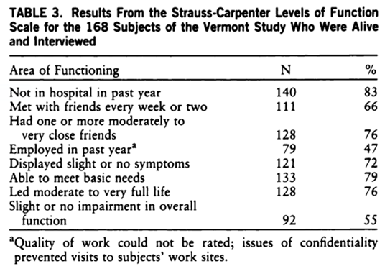
These “unbelievable results, demonstrating majority recovery even for this “hopeless” group of people, have never been scientifically challenged. In fact, they have been replicated repeatedly in other settings. Yet they are still not included in standard psychiatric education or anywhere in mainstream public mental health literature. The proven widespread reality of recovery tragically continues to be resisted and hidden.
The recovery movement often seems idealistic and unrealistic to outsiders, but it has been built by people with severe mental illnesses and the people who live and work alongside them who deeply know the practical difficulties involved. The idealism comes not from a hopeful theoretical construct, but from the lived experience of overcoming the terrible suffering that often accompanies serious mental illnesses. When the hard work pays off and someone is able to enjoy life again and find meaning, it often feels miraculous.
Recovery can begin, accelerate, slow down or even temporally end at any point of the mental health system and/or services provided in conjunction with a mental health care service package, or lack thereof. The rate of a recovery process depends very much on the availability and efficacy of services and supports, (not only within the mental health sector) and whether it is built on the premise that a person is a unique individual with a unique set of needs, challenges and preferences. It is important to also understand that every individual’s preferences are derived from their experiences and from life events that occurred in the context of these experiences and in the context of their environment or community setting – this makes us unique.
Elements that lead to recovery are different for every person. Various of elements that, in combination, are found to be beneficial to individuals, and can range from peer support, mindfulness practices, spirituality, psychotherapy, medication, positive attitudes, to work and employment, sharing recovery stories – the list is really long.
- Staff who were working with people who did not engage and collaborate well with the standard medical model system – including homeless people, people who abuse substances, people who refuse treatment, incarcerated people, traumatized people, etc.
In many places there are two basic levels of care, either outpatient clinics, for people who are self-responsible and collaborative with their appointments and treatment, and hospitals, for people who are poor self-coordinating or uncooperative to be cared for either voluntarily or not. Either limited funding for hospitals and/or a deinstitutionalization movement often leaves hospitals overcrowded and inaccessible and many people in need in our community without treatment. When they won’t or can’t come to clinics and there are problems, the burden typically falls on families, police, and jails.
There have been a number of efforts to reach these people both from people within the mental health system and outsiders, ranging from Assertive Community Treatment (ACT) teams to Homeless Drop-In Centers, from mental health and drug courts to AA meetings. To be successful, each of them has developed, usually pragmatically and organically, by figuring out what works in the trenches. Oftentimes, people who choose to work in places like these, with people who are rejected by most of society, have personal or spiritual reasons for working there. Staff may break out of traditional professional roles and boundaries to reach out to and truly engage these people by:
- Leaving the office to meet people where they are, where they’re more comfortable than the staff is
- Using self-disclosure and decreasing emotional distance to connect with people
- Focusing on practical assistance, including charity and benefits, more than treatment, at least at first
- Being very flexible about accessibility and attendance and behavior
- Focusing on building engagement and motivation for change, rather than expecting it as a prerequisite
- Including non-professional and peer staff
- “Case management” assistance with obtaining benefits and services form other agencies
Despite the ongoing reluctance of the traditional mental health system to adapt these practices, they have been widely incorporated into recovery-based services, which overall dramatically increases the accessibility and usefulness of services for many people who are “treatment resistant”.
As these people and programs have grown within the recovery movement, a set of specific skills has emerged to meet a variety of common engagement challenges:
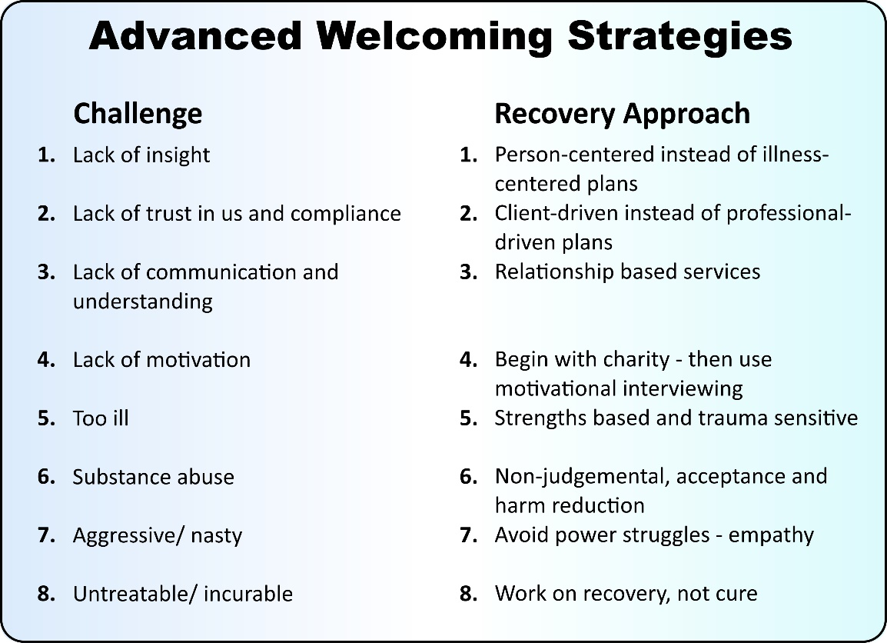
- Rehabilitation staff who saw people’s lives limited artificially by systematic hopelessness, lack of opportunity and inclusiveness, and prejudice.
Conceptualized similarly to medical rehabilitation, psychiatric rehabilitation focused on rebuilding function to be as productive as possible. Early influential pioneers included Dr R P Lieberman at UCLA with his behaviorally based skill building training modules which were translated into numerous languages in the 1980s and 90s and Dr Bill Anthony at Boston University who focused on “supported”, in-vivo services for higher education and employment using a “choose, get, keep” model. Both of them became prominent leaders of the recovery movement.
Supported employment has been one of the most successful, empowering, and stigma busting of the psychiatric rehabilitation services. Employment and work, whatever type of occupation or profession, has been highlighted by individuals with mental illnesses as an important factor in their recovery and giving meaning and identity to them as individuals. Employment and work has the potential of promoting self-esteem, confidence, self-worth and a sense of being valued, all of which are important factors for recovery. The routine and a structured environment that employment and work provides can help a person cope with symptoms of a mental illnesses, and independence is promoted where employment and work is rewarded financially. Persons with mental illnesses however experience far less access to opportunities in employment or work that could enable them to become self-sufficient and contribute positively to the economy.
In turn, poor mental health impacts on productivity and physical health, and costs the global economy approximately US$2.5 trillion per year – if business continues as usual, this figure is expected to increase to US$6 trillion by 2030, while low-and-middle income countries will bare roughly one third of the costs. It is also estimated that mental illnesses will account for more than 50% of the economic burden of disease over the next two decades, higher than cancer, diabetes and chronic respiratory disease combined. From this it is perceptible that mental health should thread throughout every sector of society, through harnessing all the elements of the recovery model, most of all within the workplace to create a working environment where all employees are able to thrive.
The concept of psychosocial rehabilitation is aimed at management of symptoms and improving functioning, through teaching emotional, cognitive, and social skills that would empower a person with a mental illnesses to live as independent as possible. Psychosocial rehabilitation tends to focus more on role attainment and performance rather than skills and functioning per se. A term associated with psychosocial rehabilitation is reintegration of persons with a mental illness into the community, even following long-term hospitalization, therefore focusing on deinstitutionalization, inclusion and recovery.
The Club House Model has a longstanding history, and is a form of psychosocial rehabilitation – a community-base and non-residential service. The clubhouse model has its roots in a support group formed in 1943 inside Rockland Psychiatric Center in New York; when people were discharged they met in New York City, initially on the steps of the New York Public Library to continue supporting each other. The group called itself ‘We Are Not Alone’ (WANA), they raised funds, purchased a property and called it ‘Fountain House’. Membership in a club is open to anyone with a serious mental illness, is voluntary, and never expires – it promotes autonomy and human rights.
All three of these services – psychiatric rehabilitation, psychosocial rehabilitation, and clubhouses – tend to be considered add-on services for people who are doing well with their psychiatric treatment, and which can be provided if funding permits (which it rarely does). In practice, many people are more motivated to participate in treatment services if they encounter challenges to their rehabilitation efforts as they try to rebuild their lives and reintegrate into their community, than are motivated to participate in rehabilitation because their treatment has reduced their symptom burden and they feel ready to move on. In the recovery model these “quality-of-life” services are often the core rather than a supplement.
Narrative: Charlene (South Africa)
After I was diagnosed with schizophrenia I was hospitalized for up to 6 months at a time over a 4 years period, and was considered by the professional team to make no progress and that my functioning was declining, despite various medications prescribed – it was decided that a psychosocial rehabilitation center would perhaps be a better option and an alternative to hospitalization. I spent 2 years in a psychosocial rehabilitation center – probably the most helpful intervention that got me my life back, even though it had its deficits to provide what would be considered a recovery approach, but it was far better that spending time in psychiatric hospitals. Living with my peers in the center allowed me to be “me” without fear of prejudice and conviction just because I had a serious mental illness, while I was trying to get direction in my life. I was able to rebuild my life at my own pace, discover coping mechanisms that worked for me, and I was given the responsibility for my own mental health. Having control over my own life and being independent always had been most important to me. Since then, I have built a successful career in mental health advocacy and was given the opportunity to work globally, and today I am the CEO of an international lived experience organization that I founded in 2018.
For rehabilitation to translate into community integration, there must be sufficient opportunities in the community (for example independent living skills are only valuable if there is affordable housing available and employment skills are only valuable if there are jobs available). Oftentimes these opportunities don’t exist, stifling recovery. Larry Davidson, another leader in rehabilitation from Yale, has moved beyond practical techniques to attacking stigma and social barriers, which can be more significant barriers to recovery than symptoms for some people.
The historic existence stigma, myths and misperceptions about people with mental illness – being perceived as violent, mad, lazy, possessed by demons and need ritualistic interventions, and incapable of positively contributing to society or the economy, are all very disempowering, and can lead to coercive practices, all kinds of human rights violations, exclusion and prevents access to life opportunities.
Fortunately, the increased global recognition of the importance of the role of persons with lived experience in mental health (both at individual and systems levels) has gained momentum; with academics, clinicians, researchers, and mental health organizations that placed an emphasis on improving the status quo through peer support systems, and accessible and quality mental health care and service delivery.
Built on the premise of recovery, recognition of the individual’s abilities and not their disability leads to empowerment. Empowerment by means of improving mental health and human rights literacy, inclusion in socio-economic development and by developing lived experience leadership in mental health are important factors for advancing recovery. Unfortunately, poor access to education along with a lack of access to adequate information are contributing factors that result in low mental health and human rights literacy among the more disadvantaged of people with lived experience who are subjected to social and economic inequalities. For some countries today, it is still unimaginable that someone with a mental illness can in fact be meaningfully employed, let alone employed within the mental health workforce, for example as Peer Support Workers.
Empowerment and participation of persons with lived experience is acknowledged at international level as fundamental to advance the human rights agenda. The Lancet Commission on Global Mental Health and Sustainable Development² which was launched in October 2018 at the Global Ministerial Mental Health Summit in London in the UK places an emphasis on lived experience participation and role in advancing the global mental health agenda.
The World Health Organization describes stigma and human rights violations as the ‘hidden burden’ of mental illness that impose negative consequences on the person, causing humiliation, isolation and unemployment. Stigma and discrimination in mental health has had a direct impact on the quality of life of persons with mental illness, by limiting or denying individuals’ access to life opportunities, suitable housing or living conditions, and quality health care. Stigma has exposed persons with mental illness to a range of human rights violations and injustices for decades, and appears to be so engrained into mental health that progress to eliminate the prejudice against persons with mental illness has been far too slow.
Persons in recovery who have spoken out about their lived experiences have made a valuable impact on changing negative attitudes and misperceptions towards mental health, forcing people to see a person and not a disorder or disability. Evidence has indicated that contact-based education, such as sharing recovery stories, is one of the most effective strategies to reduce mental health stigma.

Narrative: Shaun (New Zealand)
Driving to work as a mental health nurse one day, I made a decision to end my life, I drove my little car towards the concrete supports of a motorway bridge, but the car became stuck before it could impact. I had failed at even doing that correctly! I was in my 40s, married with my own house and car, a father of two beautiful daughter, but I was in so much pain that all I wanted in life was to die and get some relief from the mental pain that I felt was unbearable.
During the subsequent hospital admission, I was diagnosed with severe depression-I was unaware that this had built up in me and suddenly come through in the form of suicidal feelings and intent. I found psychology input really helpful in my recovery journey - an opportunity to talk about what happened to me, rather than the discussions with the psychiatrist about what was 'wrong' with me.
Peer support would have been useful, but wasn't formally available, however my connections with my fellow 'mental health patients' were helpful in putting my issues into perspective.
A combination of medication and Electro-convulsive therapy probably saved my life, but also left me with temporary and permanent negative consequences.
Some nursing colleagues were supportive and empathetic when I returned to work, however others actively avoided me. I was the embodiment of what they feared: The mental health nurse that became the 'patient'. This stigma, along with questions from management about my capability post-breakdown, caused me to be sidelined away from the modern acute unit to an old 'asylum' to help with the closure of that. However, this was really rewarding, finding homes in the community for older persons who had been institutionalized for decades was great work and it sparked my interest in peer advocacy.
A year later I was the manager of the local mental health advocacy project. A year after that I was the Managing Director of the largest mental health advocacy organization in the country. From the day of my discharge from hospital, I joined with a few other mental health workers, who had experienced mental ill health themselves and we commenced plans for a national organization, by and for peers who were in recovery from mental ill health. Several years later 'VoX-Voices of eXperience' was launched and we became the inaugural Board, with three staff and a membership that grew to thousands of peers. That was at a good time in the country, as there were opportunities to influence new mental health legislation, the first ever review of mental health nursing, a Recovery network, an Advocacy peak body and the formation of a cross party group in the Parliament on mental health. We stood on the shoulders of those who came before us and were supported by our members in recovery, to have a strong voice in reform.
I had transformed from the man in so much pain, to the advocate with so much to gain!
- Other recovery programs and staff, especially 12-step substance abuse and trauma recovery
Recovery is not a novel concept invented by the mental health community. Recovery has a long history of being the expected, positive process people use to overcome loss and destruction. We are all familiar with the idea of recovering from our house burning down or a painful divorce or the death of a child. Recovery is a human experience we’ve all been through in one way or another. Similarly to the work by Elizabeth Kubler Ross defining the stages of grief as we face death and dying (denial, anger, bargaining, depression, and acceptance), many people have sought to define stages of recovery. One of the authors, Mark Ragins defined four stages of recovery in his small book “A Road to Recovery”:
- Hope – we have to believe a better future is possible to work towards it
- Empowerment – we have to believe in ourselves enough to believe we can achieve that better future
- Self-Responsibility – we have to take intentional steps, even if uncertainly, towards that future to make it happen
- Achieving meaningful roles – we have to expand our lives beyond the loss and destruction to have meaningful activities, self-identity, and connections to others.
These universal stages apply to people with mental illnesses too.
We’re even familiar with the idea of recovering from a medical condition like malaria or a broken leg or even cancer. In these situations we tend to visualize treatment and rehabilitation services more than the universal stages and personal growth, but in practice achieving recovery even from medical conditions often requires personal investment and growth as much as treatment and rehabilitation.
By the time we get to mental illnesses, it often seems we’re too overcome by the difficulties in connecting to people, in understanding what they’re experiencing, and in sustaining hopefulness, so that we assume that recovery is impossible for them and turn our attention elsewhere – to stabilization, symptom relief, avoiding dangerousness, and decreasing social burden.
Two areas of mental health have separated from the established mental health system and continued to pursue recovery aggressively: substance abuse and trauma. Many people being served and working in the mental health system have extensive experiences with substance abuse and/or trauma and they have brought to the recovery movement, not just their challenges, but also their positive experiences with recovery and their expertise.
Alcoholics Anonymous and the multitude of other 12-step programs have developed a sophisticated approach to recovery: It includes an intellectual level (e.g. completing a 1st step worksheet documenting how alcohol has made your life intolerable to clearly see the negative impact in a number of life areas), an emotional level (e.g. completing a moral inventory, sharing it with someone else, and when possible making amends to the people you’ve harmed to clear underlying accumulated shame and guilt) and a spiritual level (e.g. turning your life over to a higher power as you perceive it and getting to know that higher power more deeply). It is a relationship-base program, relying almost entirely on peer support, both in self-help meetings and a personal sponsor. While AA conceptualizes alcoholism as an illness, it conceptualizes recovery as a personal journey, that is often ongoing.
Trauma-informed care also has a sophisticated approach to recovery. They begin with asking what someone has experienced rather than what’s wrong with them. They try to understand how people have reacted to trauma throughout their lives, defending themselves to survive, adapting to thrive. They believe that every “symptom” was developed to help the person and has a role to play that must be understood before giving it up or growing beyond it. Behaviors like self-soothing by rocking or headbanging, dissociating or self-harm to avoid feelings or take control of them, hypersensitivity to people around them, hypervigilance expecting dangers everywhere, hyper-alertness preparing to meet those dangers, and “acting out” meeting the dangers are all understandable within the context of what the person has had to do to survive. It’s important to have an emotionally safe place to let down defenses, to re-examine one’s life and our reactions to it, to begin to take steps to integrate those experiences, instead of blocking them off, to recover parts of ourselves. Trauma recovery is a process that can’t be rushed. Each person must progress at their own pace.
Many typical psychiatric services actively underestimate the prevalence and impact of substance abuse and trauma in the people being treated there. Sometimes these people are actively avoided or rejected, or their substance abuse and/or trauma experiences are neglected within plain sight. The sophisticated recovery techniques developed to help these people recover are also too often neglected or deflected, referred out to somewhere else. “I don’t deal with those people, so I don’t need that training” and “I need more training so I can deal with those people” are familiar refrains.
Once they believe that we are not only going to see them in their entirety but also that we value and are willing to learn from their expertise, the recovery movement has delighted many people in the substance abuse and trauma recovery communities and been embraced and enriched by them.
To a lesser, but perhaps growing extent, the recovery movement has also shown a willingness to learn from people who have experienced spiritual crisis and spiritual recovery as well as other forms of indigenous and cultural healing and recovery.
In summary, these four roots – service-user-based advocacy, staff engaging challenging populations, rehabilitation, and other recovery programs – have organically grown together building today’s recovery model and movement.

Part 2: Three major recovery transformations:
No clinician is against recovery. We all want the people we work with to do as well as possible. But we tend to believe that the reason people aren’t recovering is because of something too wrong with them, or because there are inadequate resources, rather than because we aren’t using the most effective approach. We tend to think our approach is the best approach possible, whatever we’re doing. The recovery model challenges those common attitudes, claiming there is a better way, centered around three major paradigm transformations:
- From Illness-Centered to Person-Centered: Moving from centering our efforts on the treatment of illnesses and the reduction of symptoms to a holistic service of people and the rebuilding of lives. Recovery is something a person does, not what an illness does.
- From Professionally-Driven Compliance to Client-Driven Collaboration: Moving from professional directed relationships emphasizing informed compliance with prescribed treatments to individualized relationships emphasizing empowerment and building people’s self-responsibility. Recovery isn’t something a professional can do to a person. It is a process they must engage in to help themselves.
- From Deficit-Based Cures to Strengths-Based Resilience: Building hope for recovery upon each person’s strengths, motivations, and learning from suffering rather than upon the competence of professionals and medications to reduce or eliminate the burden of their illnesses. Recovery doesn’t happen when the person never has any more symptoms, even serious ones, but when they have the strength and resilience to handle whatever symptoms occur.
- From Illness-Centered to Person-Centered:
Generally, current mental health systems are focused on treating mental illnesses rather than addressing the overall needs and life goals of people struggling emotionally or mentally. Mental health professionals are paid to diagnose people with illnesses and to do our best to treat the symptoms and rehabilitate the disabilities associated with those illnesses. Decisions, like whether someone should have government funded disability checks, support in vocational rehabilitation or education, subsidies for housing or transportation, decision making over their money, ability to vote, or enter contracts, etc. all tend to be based on medical information regarding the impact of their illness. Unfortunately, a great deal of the day-to-day burdens people face tend to fall outside the expertise, funding, or operations of mental health systems as a result, leaving many people looking for alternatives.
The recovery model puts the person at the center, instead of the illness. This may seem like a semantic difference, but it is key to implementing the entire recovery model. Instead of beginning with a diagnostic assessment and a diagnosis, recovery services begin with an engagement into a helpful relationship, regardless of if they agree they have an illness or not. Instead of focusing on relieving symptoms, recovery focuses on meeting people’s needs and supporting their life goals. It may be that having reduced symptoms will help them achieve their goals, but it also may be that may be that improving lives will help reduce symptoms and disability.
Recovery also has the potential of integrating approaches that examine the impact of social factors (like racism, poverty, family and cultural factors, and even climate) on lives and illnesses.
This table summarizes the differences between illness-centered and person-centered approaches: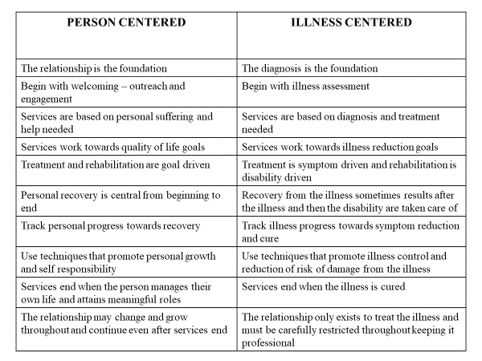
This person-centered approach legitimizes “non-medical” approaches to improving lives, like housing, supported education and employment, money management, and community integration services, often provided by “non-medical” personnel.
It also broadens the therapeutic approaches that can be integrated. As discussed above, two areas within mental health, substance abuse and trauma, have already been using a recovery-based approach, and both are person-centered. Although Alcoholics Anonymous says that alcoholism is an illness, that is nowhere in the 12-steps which is entirely a process the person goes through, intellectually, emotionally, morally, and spiritually in order to recover. Similarly, although DSM-V has PTSD included as a diagnosis with specific symptoms, the process of healing and recovering form trauma is a personal process moving “from victim to survivor to thriver” rather than a process centered on relieving the symptoms. These two areas, substance abuse and trauma, are quite prevalent in mental health programs, likely even the causes of many people’s diagnosed illnesses. In a recovery-based system they can be fully integrated into “dually-diagnosis competent” and “trauma informed” services.
Being person-centered does not mean denying having a mental illness, nor is the recovery model anti-medications, but it does place the person at the center, focusing on their issues as they see them, which may or may not include believing they have an illness. This crucial flexibility allows recovery services to “meet people where they’re at” without getting stuck forcing “insight” into an illness. Listen to this range of stories of lived experience, all of which led to recovery:
Narrative: Claudia (South Africa)
The key components that positively contributed to my recovery are 1) yoga and meditation, 2) attending consistent therapy sessions and 3) routinely taking my prescribed medication. Yoga and meditation have been incredibly helpful in aiding me to feel grounded and supported during practice particularly during times of increased anxiety and OCD related feelings and actions. From a young age, I was particularly interested in spirituality and the benefits of practicing mindfulness and grounding techniques; little did I know that they would become a bigger more profound part of a story in my life. Also, I am a firm believer in routinely taking medication for my mental health condition. While there were challenges in the initial stages of diagnosis in finding the correct combination of medication for me and my body, in the long term, the correct medication helped me be in a position where I could act and react rationally and to make good decisions when coping with stressors. Holistic practices have helped me become a stronger, more focused individual. On the other hand, however, I cannot stress enough that being part of a toxic environment set me back on numerous occasions.
Narrative: Wariimi (Kenya)
I was diagnosed with severe depression and anxiety disorder in June of 2015. It has not been an easy journey, mainly because at the point of my diagnosis there was very little resources/ information on depression in Kenya. I had one friend who had been battling depression, unfortunately, he was not able to assist me much because he was fighting his own battles. This made me feel so lonely and confused at the beginning but with time I was able to put some coping strategies in place that have helped me manage the condition. The 3 most prominent aspects that has helped me in my recovery has been, my connection with religion; support from family and friends and journaling.
My spirituality has given me hope to keep moving forward. Reading scriptures gives me hope for a better tomorrow, it gives me strength and peace to keep moving no matter how tough things get.
I am really blessed to come from a close knit family and I also have close friends who have supported me from day one. At the beginning everything and everyone was confused and I realized I needed to be patient with them because we were all learning. I share mental health information with them, and when I am not in a relapse I let them know how to handle me in different scenarios/ situations. These people in my life are always willing to learn and understand about my condition and I believe that it has made dealing with my condition much easier
Writing down all my thoughts helps relieve stress and helps me organize my thoughts. I am able to easily identify triggers, since I am able to go back to it and identify what would be causing a relapse. It also helps me process my emotions whether good or bad. In my journal I have a section where I write three things I am grateful for every day, and during the tough days I read them and this gives me hope to keep going.
Narrative: Sandra (South Africa)
Similarly, to how there is no one universally accepted definition of recovery within the scope of mental illness, there are no two stories that are the same. When posed with the question about what key aspects have contributed positively to my continued recovery, three factors stick out to me: acceptance, education and clemency.
Acceptance has, by far, been the most pivotal role player in my recovery. After many years of denial, I finally accepted my diagnosis. With that (through much trial and error, admittedly) an effective course of treatment and a responsibility to myself to be better, in every way possible. Acceptance and support are also irrefutably intertwined.
Education has always played a significant role in my life. Personally, professionally and medically. Learning about my condition, medications, treatments, self-care and most recently, my role within mental health advocacy continue to be the strong foundations on which I build on. Advocacy in particular, has afforded me the opportunity to interact with people globally who have mental illness establishing a sense of belonging that I have seldom felt before.
Shame and guilt often go hand in hand with a mental illness. Being unforgiving of yourself is a heavy burden to carry. I have come to accept that granting myself clemency, as hard as it might be, is necessary to my holistic recovery.
As cliché as it might sound, I try to live and love my life to the fullest. For me, this is quite possibly one of the simplest but greatest achievements I ever could have realized.
Narrative: Alexandra (United Kingdom)
Two key aspects have contributed positively to my recovery process. The first has been my use of prescription medication. Prior to being on medication, I struggled to survive: I found it difficult to perform basic tasks, experienced suicidal thoughts, could hardly get out of bed in the morning, and experienced crippling anxiety. Once I found the right combination of medications that worked for me, I was able to complete the small tasks that together, enabled me to function daily. While medications have helped me survive, therapy has given me confidence to thrive. Once a month, I see a supportive and honest individual who has an objective view of my life. Together, we work towards the goals I have set for myself and discuss how to overcome any challenges. She reflects my best-self back to me, and that validation has given me the confidence to present myself to the world. It has been a critical part of my recovery process, and I cannot recommend it enough.
Narrative: Victor (Hong Kong)
The key aspects that have contributed positively to my recovery has been: social connectedness; therapeutic risk taking and giving thanks in all.
Recalling my journey in recovery of mental illness, social connectedness has been a major antidote to my depression and anxiety. A non-judgmental attitude from people around me is crucial that in showing their willingness to connect with me despite knowing my mental struggles. It is obvious when “I” am connected as “We”, “Illness” will be transformed into “Wellness”. As a matter of fact, when I am having strong bonding with others and receive recognitions from them, my status of recovery has been a lot more positive.
In the early stage of my recovery, I was working a few hours a week for a social organisation, compared to a previous full-time job where I was not having satisfactory attendance mainly due to the side effects of the psychiatric drugs. One day, the senior manager of the organization talked with me and found that I am enthusiastic in teaching. Without much hesitation, she arranged me to take full accountability of a mathematics class with elderlies in the organization. It was such an astonishing moment in my life that I strongly experienced unconditional trust from her and I later know this is a big act of therapeutic risk taking.
I am learning to give thanks in all, including adversity, throughout my recovery trajectory. It may seem strange to many people about giving thanks in bad moments, but to me now, it is possible and even beneficial to my mental health. I am not meaning to lie to myself that I feel good in adversity. This is possible based on the acknowledgment of only one thing is certain: uncertainty. Take my adversity when I first entered psychiatric ward 12 years ago as an example, I thought I was totally certain that my life was ruined completely. Today, on the flip side, I find the situation when I was diagnosed to have mental illness was totally positive in the sense that it has shaped me and granted me a very promising life. After all, I finally realize I can never be certain about anything happened in my life to be ultimately positive, and negative. Once I have let go of my authority to determine the goodness of things happening around, I could then gradually accept and even embrace every tiny issue that I encounter. This is easier said than done, but not impossible. I found space and peace in my heart to contain sadness and anger after I practice giving thanks in all.
Narrative: Karina (Denmark)
I experienced a pervasive loneliness and a pressure from a society, that I didn’t feel like I was capable of being a part of. This feeling had been a part of me for so long, that I tried to commit suicide. That is how I ended up in the mental health system.
When I entered the mental health system I got a name for what I was experiencing. Actually, I got several. Severe depression. Paranoid schizophrenia. Existential anxiety. Names which didn’t accommodate what I was experiencing, however “symptoms” and “delusions” is a much bigger part of my journal, then the underlying reason why I that night decided to end my life. I remember the meeting with the doctor, where I told him about the voices I have been hearing my whole life. The doctor explained to me, that hearing voices is not normal, and that I needed to be medicated for them to go away. They had to be the reason for my misery. However, they are not. It was my connection to society.
While I was hospitalized, I talked to one of the other patients. He was also hearing voiced and had, like me, trouble understanding why the treatment centered on getting rid of the voices rather than on the reason why we ended up in the mental health system. He told me about a hearing voices network. When I was released from the hospital, I sought out the network. This was a place where I did not feel sick. I was amongst peers and talked openly about my voices. The voices are only present when I feel pressured. They actually take care of me – and remind me to take care of myself. This clarification gave me so much more than a diagnosis, which had made me question who I am and what I wanted out of life. I never returned to the mental health system. Even in my darkest hours. I stayed in the network for a few years, while I tried to find my place in society. I chose the wrong path many times, until I found out what gives me strength. Today I work as a gardener. When I was hospitalized, my mom would bring med plants, which I still have today. My home actually kind of looks like a small jungle now. I watch plants grow every day, because I take care of them. Moreover, I am good at it. The voices still drop in occasionally – when I feel pressured or overwhelmed by loneliness, they are there to take care of me. Not because I am sick – or ever was. Now I am part of a small network of plant enthusiasts. We drink coffee and talk about the ups and downs in our lives under the shadow of a palm tree in my living room. I have found a place where I belong, but I am still careful to not speak about my voices, because of the perception that hearing voices is not normal.
- From Professionally-Driven Compliance to Client-Driven Collaboration:
The past approach to mental health had been marked by “controlling” symptoms of a diagnosis, focusing predominantly on the medical model that has been known to often result in the denial of human rights of persons receiving treatment, especially within institutional care settings. Paternalism in mental health has had serious implications on infringing on the right to legal capacity, independence and dignity – and disempowerment has been a product of paternalism. In contradiction, the present approach to mental health has seen a shift to rather the “management” of, other than “control” of symptoms through a holistic and comprehensive service package that combines medical, social and human rights models of care. This shift has initiated hope for recovery rather than a life sentence of being deemed incapacitated and worthless. The scales are being tipped, where power imbalances are being corrected, placing users of mental health services in the position of power over their own treatment and recovery, and in a partnership with their professional treating team.
Key principles for effective partnerships with person with mental illness must be built on respect, integrity, trust, equality and dignity. Dignity is an integral part of personal recovery and everyone has a right to dignity.
The World Dignity Project conducted a qualitative research study in 2018 with persons with lived experience to add perspective to get a better understanding of dignity in the mental health based on patient experience and to develop specific conclusions for ensuring dignity in patient experience and equality of treatment. The study generated powerful responses from persons with lived experience on negative and positive patient experiences. Themes from the lived experience responses related to negative patient experiences included: “you treat me like a number or a problem, not a person”; “you take away my self-esteem, and hope”; “you don’t consult me about my treatment”; “your response to me is medication”; “you allow your prejudices to influence how you treat me”; “you don’t listen to me”; “you lock me away”. Themes from the lived experience responses related to positive patient experiences included: “you give me a safe place where I feel supported, valued and loved”; “what I feel is real – you validate my feelings”; “you listen to me without interrupting”; “you give me control by involving me in decision-making”; “you give me tools I can use”; “you give me hope for a future when this is behind me”; “you communicate with me throughout”. The respondents in the study highlighted 4 key areas for improvement in mental health treatment, and included: human empathy; creating a safe space; respecting dignity and rights; and nurturing a sense of control and hope.
Recovery isn’t something one person can do to another person. It’s something the person does for themselves. Other people can have a relationship that supports changes to recover or assist someone in learning things they can do to recover, but one person can’t “recover” another person. This truth, has three major implications:
- It’s important to avoid coercion, even if it’s well intentioned, because for many people forcing them to do something is likely to build resistance, and unlikely to lead to internalizing change. The strategy of “motivational interviewing” has developed as a way of building internal motivation for change by meeting people where they’re at (pre-contemplation, contemplation, planning, action, sustaining change), allying with them to decrease their natural ambivalence and resistance to positive changes.

- It’s important to engage people in the process of recovery. Most people are more willing to work on their own goals and plans than other people’s goals, so “client-driven” goals form the first part of recovery plans. Goals can grow and develop as people do. “Shared decision making” is a process of combining the person’s own expertise in themselves with the staff’s expertise in helpful strategies. Patricia Deegan’s Common Ground Guides to help people use their psychiatrist visits more effectively and to develop their own “personal medicine” to promote their recovery help combine personal goals with the tools, including medications, to achieve them. Mary Ann Copeland’s Wellness Recovery Action Plans (WRAP), another example of building self-help plans, include three levels of self-care (maintenance when things are going well, more support for when there are stressors, and even more for when there is a crisis).

- The person’s own perspective of themselves and their challenges, which traditionally are devalued as “subjective” or “lacking insight”, are more important to creating an engaging, client-driven plan than the staff’s perspective, which traditionally is considered “objective” and what’s “really wrong”. It’s more important for a staff to attain an empathetic understanding of “what it’s like to be them” and “seeing things through their eyes” than it is to attain a compassionate understanding of “what I can do to help them as I see their problems.”
This shift can be the most unsettling for professionals (and families). They resist giving up power, fearing they will be forced to support unethical goals and plans, “turning the asylum over to the insane”. It can be hard to realize that recovery is far more likely to result from empowering people and from supporting their choices, than it is from coercing them to do what “we know is best for them.” Being successfully engaging, motivating, collaborating, empowering, and stimulating someone’s own strengths requires a great deal of skill, training, and experience.
- From Deficit-Based Cures to Strengths-Based Resilience
The medical model is built upon experiences with acute conditions, like infections, injuries, and rapidly growing tumors, where recovery usually results from symptom relief and curing the acute problem. But for chronic conditions, like diabetes, dementia, and many mental illnesses, recovery usually results from being able to maintain wellness and responsibility for self-care and being able to replace professional supports with natural supports while rebuilding a meaningful life. The goal is not to cure a chronic condition, but to recover life even with it. While its helpful to reduce symptoms, its often more important to build resilience. As a result, our focus should move from working on reducing our deficits, to building our strengths.
A professionally-driven, deficit-based recovery sounds like this: “I’m so grateful that I had good psychiatrists and therapists who figured out my diagnosis, prescribed medications and therapy that helped me control my illness, cared for me, making decisions for me and getting me the benefits and supports I need. I know I can always rely on them if my illness recurs to take care of me again. I can rely on their strengths.”
In contrast a client-driven, strengths-based recovery sounds like this: “I wouldn’t have wished my condition on my worst enemy. The loss and suffering have been unimaginable unless you’ve experienced it too. But the battle to overcome my condition, to reclaim my life has brought out strengths in me I never would have known I had, including some of the things I’m most proud of. It’s made me realize what’s really important in life. It’s been painful, but there have been gifts from my wounds, and blessings in disguise.”
The first person is dependent. The second is resilient.
We can work on building strengths from four perspectives:
- Improved social determinants of health – including financial strength, social connectedness, family, political enfranchisement, secure housing, and connections to social and spiritual institutions
- Protective factors to avoid risk factors and stressors from damaging us – including money for emergencies, housing, family, other adult connections, meaningful roles and self-identity, and spirituality
- Self-efficacy and self-responsibility – including managing internal emotional states, taking a more active role in your own life, improving goal achieving skills, maturing emotionally and psychologically, building interpersonal skills, and building spiritual skills
- Finding strengths in struggles – including both inner strengths and supports all around you that you can reach out to and rely on
Notice how much overlap there is in these lists, meaning that whichever approach someone takes, they’re likely to benefit in all four areas.
All three of these transformations – person-centered, client-driven, and strengths-based - are difficult, and essential to promote recovery.
Part 3: Contrasting medical model, rehabilitation model, and recovery model – What’s really different about recovery? A case study:
Programs all over the world are being told they need to be providing recovery-based services. When they ask what that means they’re supposed to be doing differently, they’re usually given either a set of recovery-based values - like client-driven, person-centered, goal-driven, empowering, and strengths-based - or a new set of paperwork requirements to add to what they’re doing. Neither approach meets them where they’re at; providing direct services to challenging people trying to help them with their mental illnesses. They don’t usually understand what they’re “doing wrong” and why they need to change.
The medical model conceptualizes the process of recovery as:
- The fundamental problem is the symptoms of their mental illness.
- Diagnosis, assessments, treatment, monitoring, and achieving success are focused on symptom reduction.
- Once the illness is treated, other services may be needed to help people deal with residual symptoms, to keep symptoms away, and to rebuild lost functions or quality of life.
- Some fortunate people respond to treatment and other services to achieve recovery.

In contrast, the recovery model conceptualizes the process of recovery as:
- Mental illnesses are a highly individualized, complex personal reaction to a variety of biological, emotional, developmental, traumatic, and social influences.
- Each person's outcome is more dependent upon how they personally react, adapt, and cope than it is dependent upon the type or severity of the symptoms themselves.
- Promoting positive personal reactions (e.g., maintaining hope, self-belief, managing risks, engaging and collaborating with helpers, taking self-responsibility, being motivated to build skills and supports, finding personal and social meanings, and avoiding isolation) throughout the course of each person's illness is crucial.
- Some fortunate people find enough inner strengths and resilience to make personal changes to achieve recovery.

Let’s describe a single case in detail to try to concretely describe what’s different about recovery-based services.
Robert served in the US army in Korea, but long after the fighting was done. He mainly remembered using drugs sold to him by his sergeant. When he left the military, he was lost, confused, isolated, using drugs, and increasingly wrapped up in a religious guilt feeling that God was punishing him. He wandered the country and became suicidal. He went to a Veteran’s Administration (VA) hospital for help, but was locked in a barren ward, deprived of any means to hurt himself. After two weeks, he promised not to kill himself, so they let him out. He hated the experience and never returned to the VA for any services or benefits.
He spent the next decade travelling around, doing odd jobs and learning some construction skills. Occasionally homeless, he often lived in hotels or shelters as he moved about. He never held a steady job or an apartment of his own and had no long-term relationships or connections with his family.
Then a terrifying thing happened. He fell asleep on a bus and two undercover military agents sat behind him and implanted a receptor in his head so they could transmit satellite messages to him. These messages were very disturbing and crazy making, telling him to kill himself or hurt other people, especially black people. When he saw a newspaper report that his old sergeant had been made a general, it all made sense to him. He was being discredited so he could never testify against his old sergeant.
He went to hospitals to get x-rays to find the implant and remove it, but instead was told he was crazy. He was given meds that confused him. He felt unable to fight the machine. He struggled mightily against these messages, but sometimes did attack people. He developed headaches, severe anxiety, and insomnia. He learned that alcohol calmed him and helped him sleep, but dulled his mind and reduced his vigilance. Speed seemed to work better, because it helped him think fast enough to outsmart the machine, but then the headaches, insomnia and anxiety returned. He isolated himself, to avoid hurting anyone, and ended up living under a bridge.
Our discussion begins by comparing and contrasting the two most common mental health treatment models, the medical model and the rehabilitation model, with the recovery model.
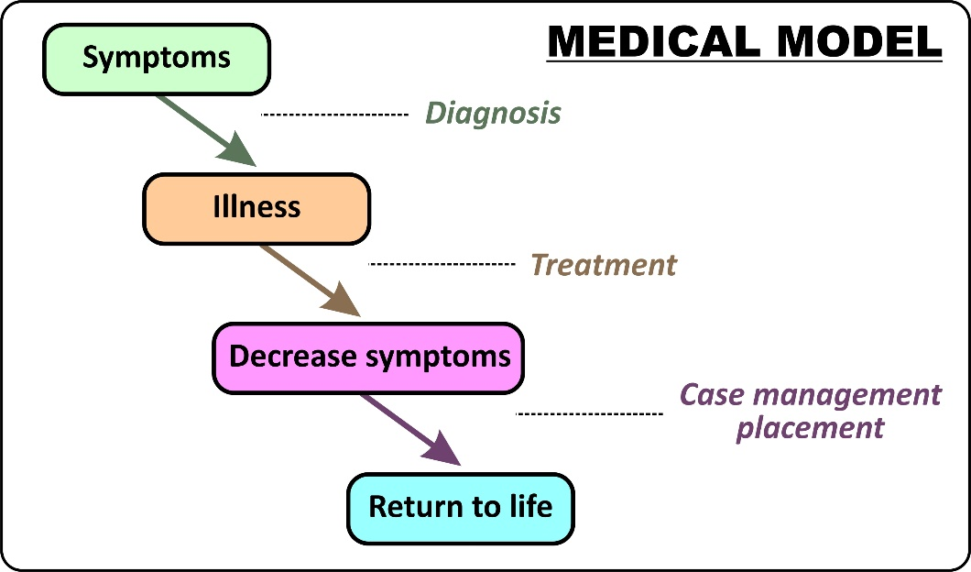
The Medical Model is predicated on the notion of diagnosing psychiatric illnesses, treating their symptoms, and helping persons with these conditions return to health and more productive and meaningful lives. However, it is a paradigm that fails to address some concerns for persons with mental illnesses. Many people with mental illnesses don’t agree that they have an illness, at least not in the way it is defined by the medical model and are often difficult to engage in treatment. Even with excellent treatment, many do not experience sufficient symptom relief from treatment alone to feel healthy enough to return to life. After most symptoms are relieved, many continue to have substantial disabilities from other factors (e.g., trauma and loss, personality issues, low intelligence, poor relationship skills, poverty, lack of education, social ostracism), not to mention the immediate and longer term impacts of involuntary and coerced treatment interventions. This leads many to seek additional, often equally insufficient, medical treatments and/or to give up on the mental health system entirely.
Robert’s Medical Model scenario: Robert was hospitalized and was diagnosed with a co-occurring mental illness and addiction disorder. The hospital staff explained to him in a compassionate, psychoeducational manner that there wasn’t any machine. They explained that he had a chemical imbalance in his brain, probably exacerbated by substance use. The brain disorder was causing his mind to misperceive reality, that the “machine” was a delusion. The good news was that medications could restore his brain’s chemical imbalance so he wouldn’t be delusional anymore.
Unfortunately, Robert refused to believe this explanatory model, even though the staff were kind and compassionate. He refused the medications and never returned to the outpatient clinic to which he was referred. Since Robert lacked insight and was struggling to meet his basic needs, he was repeatedly hospitalized on an involuntarily basis and forcibly medicated. When not hospitalized and removed from society for his protection and public safety, he would often return to a life of alienation, homelessness, loneliness, and little hope of returning to a productive life.
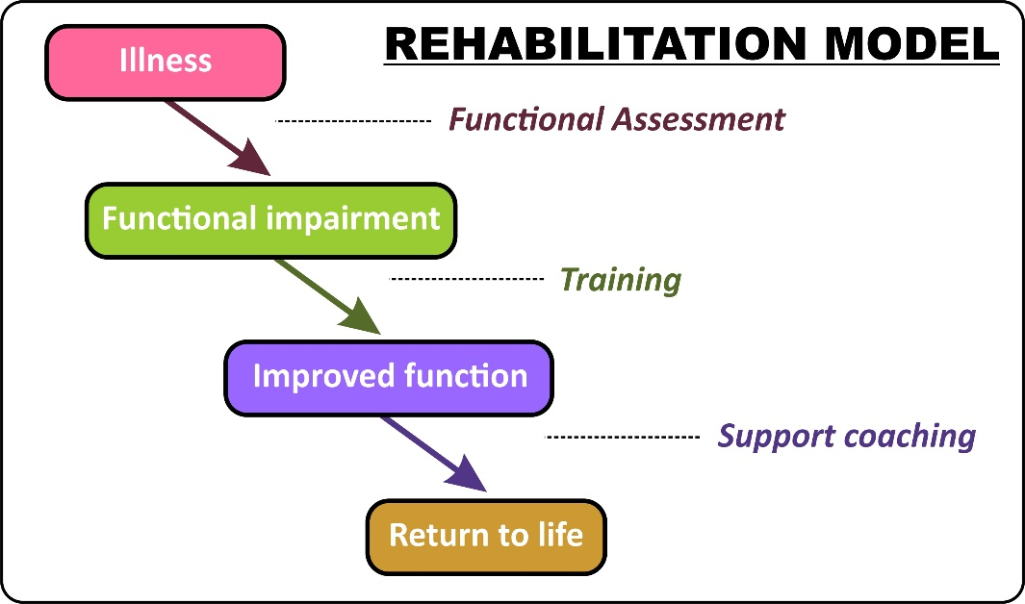
The Rehabilitation Model focuses more on functioning than on symptoms. A functional assessment leads to training to reduce deficits and build strengths. When persons are sufficiently supported and perceived as likely to succeed, they are assisted in using their new and restored skills to return to life. This model also fails for a significant number of people. It is almost always used sequentially with the medical model, based on the presumption that symptoms must be treated and stabilized before skills training and support efforts would be effective. If symptoms aren’t able to be controlled, such people are often deemed not ready for rehabilitation. This vulnerability is being actively addressed with various supportive rehabilitation techniques (e.g. supported employment, housing, education). The need for symptom control is not necessarily a prerequisite for effective functioning, but our system often reflects social stigma and rejection by not giving people with overt symptoms a chance to build functioning. The Rehabilitation model depends on sufficient opportunity: that if someone has job skills, there is a job available or if someone is able to live independently, there is an affordable apartment available. To be effective, rehabilitation has to be supplemented by community development to build such opportunities.
Robert’s Rehabilitation scenario: After being discharged from the hospital, the outpatient rehab program staff told Robert that they would help him with supportive housing and employment after he was stabilized. When he became compliant with mental health treatment (by taking medications) and maintained sobriety (by completing a drug treatment program), he would be ready for rehabilitation. Alternatively, if he felt that such an approach was too difficult, they would help him get on Social Security disability. They would then offer him housing and services in a residential program where he would receive the treatment, structure, and supervision that he needed until he could again function safely and independently. When offered these choices, he refused all services and eventually wandered off and out of contact with the treatment program.
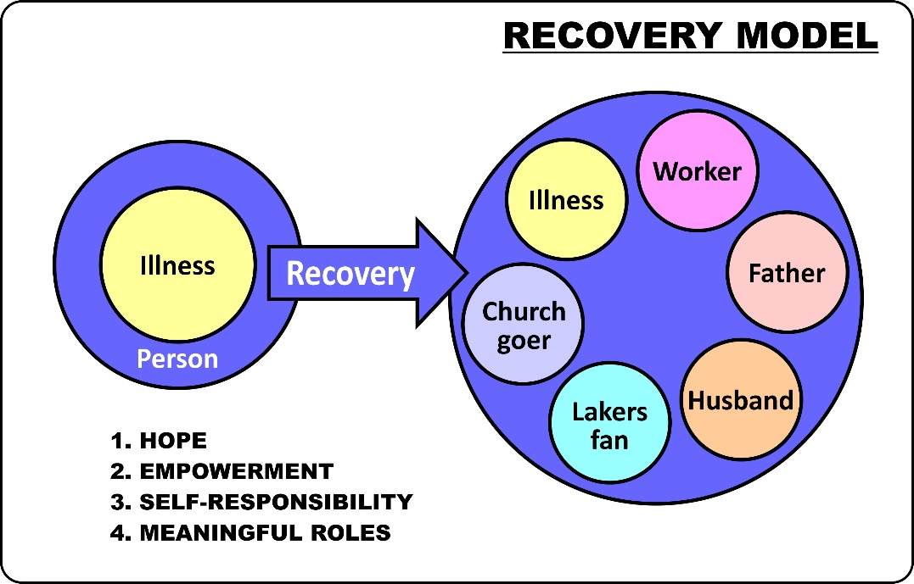
The recovery model emphasizes changes that persons make in and for themselves. When people first come for services they often feel their illness has swallowed them up. They have struggled to overcome it on their own for quite a while, but with little success. They have experienced substantial loss, destruction, and rejection, as well as self-doubt. They often feel crippled by the illness and that life is a constant all-consuming struggle. Recovery engages the part of the person that is struggling, that may still have hopes and dreams, and aligns with that part. The recovery approach helps by decreasing the impact of the illness and by restoring or expanding the rest of the person’s life. Recovery requires building meaningful roles in life.
Recovery is both a destination and a journey. SAMHSA's 2011 “working definition” of recovery was: “A process of change through which individuals improve their health and wellness, live a self-directed life, and strive to reach their full potential” (the journey portion). It went on to define four domains to support a life in recovery: Health: overcoming or managing one's disease(s) as well as living in a physically and emotionally healthy way; Home: a stable and safe place to live; Purpose: meaningful daily activities, such as a job, school, volunteerism, family caretaking, or creative endeavors, and the independence, income and resources to participate in society; and Community: relationships and social networks that provide support, friendship, love, and hope (the destination portion).
Meaningful goals mark progress along the way:
- Functions may be recovered - the ability to read, to sleep restfully, to work, to have coherent conversations, to make love, to raise children, to drive a car, etc.
- External things may be recovered - an apartment, a job, friends, playing in a band, a spouse, a car, family relationships, TV, educational programs, etc.
- Internal states can be recovered - feeling good about oneself, satisfaction, self-confidence, spiritual peace, self-responsibility, a sense of identity other than as a mentally ill person, etc.
Robert’s Recovery scenario. A homeless outreach worker, himself a veteran with a history of mental illness and alcoholism, began stopping by Robert’s encampment, bringing him sack lunches, sharing stories, and listening quietly. After several months, Robert agreed to come into a drop-in center to shower and get some clean clothes.
After another week Robert was introduced to the team psychiatrist, to “see if our doctor can help you.” As he listened to his story, the doctor didn’t ask many diagnostic questions. He asked Robert about the story of his life instead of the history of his illness. He learned that Robert was a very moral man, that he missed working, and was getting sick and tired of living on the streets. When the psychiatrist shared pictures of his family, Robert said that he still hoped he could marry and have a family some day. Rather than providing corrective insights that the machine wasn’t real and that he had a psychotic disorder that would likely respond to medication, the doctor met him where he was. He said he knew nothing about military satellite technology, but a lot about strengthening brains and dealing with overwhelming stressors. He was interested in Robert’s efforts to strengthen his brain with alcohol and speed and thought he could offer a better alternative. He offered him a prescription medication that “combines the effects of alcohol and speed that might calm you and focus your thinking”. Would you be willing to try it instead of alcohol and speed to see if that helped you fight the machine better?” He agreed.
Put simply, the goal of recovery is not to treat mental illnesses, but to help people with mental illnesses to have better lives. Recovery based services are built on service-user strengths leading to resilience, rather than the clinical mastery of the professional treating the service-user’s deficits.
The psychiatrist told Robert that he was more vulnerable to the machine by staying alone under the bridge than in a hotel room, and that he’d probably cope better if he was doing something positive instead of sitting worrying about this all day long. To take advantage of his work ethic, he was offered “work for a day – house for a day.” He could work 2 hours a day in the program’s café / lunchroom making hamburgers and sandwiches to earn a nightly hotel voucher. He was assured there would be people there who could help if he felt overwhelmed or violent and who wouldn’t lock him up. They began working together on his goal of fighting off the machine and rejoining society. They invited him to become a member of the clubhouse program.
Over the next few months he improved. The machine quieted down enough so he could relax and sleep ; the headaches went away. When he worked, the machine didn’t affect him at all. He began driving the van on catering jobs. The program staff were encouraged and offered him a permanent job and help getting a subsidized apartment.
Strengths aren’t people’s skills or talents or things we like about them. They are the resources they will use to overcome their illnesses. Strengths can be internal qualities like determination, hopefulness, self-awareness, self-responsibility, pride, a strong work ethic, family values, and spiritual faith. Strengths can be external resources like money, family, community, stable and safe housing, mentors and friends. Strengths can be discovered (or rediscovered) or newly developed. When someone has enough strength to overcome the next symptom increase, drug relapse, relationship breakup, job loss, family disappointment, or even tragic loss without falling apart, without becoming homeless or jailed or hospitalized, without losing everything they’ve worked so hard for, then they have resilience. Our goal is not to protect them from tragedies but to help them build enough resilience to handle the inevitable crises when they come.
Robert disappeared back under the bridge. The treatment team suspected that either he’d relapsed on speed or stopped taking his medication and was more psychotic. The peer outreach worker looked for him and found that neither of those things had happened. Robert was just scared and thought they were pushing him too fast. He agreed to return to “work for a day – house for a day”.
Six months later he chose to move on to permanent work and an apartment. By the time the team celebrated his achievement with a housewarming party, he’d gained so much confidence dealing with the machine that he stopped his medications. The psychiatrist continued to see him and, although his old religious guilt returned, the machine remained very quiet. He worked on his shame and guilt without meds. He began volunteering by providing homeless outreach with his old worker as a way to give back to others.
Robert felt proud of himself and the emotional closeness he had developed with the community of staff and program members who reminded him of his lost family. The program helped him find his sister on the internet and to visit her in a distant city. She welcomed her long-lost brother. Six months later he decided to move to be with his sister, realizing that he was strong enough to make it without the treatment program.
Robert never got insight. He never really complied with treatment or medications very well. His illness was never stabilized and certainly it wasn’t cured. Yet he recovered. Look back at the SAMHSA definition. He’s been on a journey and achieved a destination with health, home, purpose, and community… and a variety of staff and peers played an important role in his recovery.
Focusing on the Psychiatrist:
Psychiatric medications had historically taken a fairly paternalistic approach where psychiatrists follow diagnostic criteria and prescribe medications, more often with little to no consideration for the views or choices of the person receiving treatment regarding the prescribed medications.
Psychiatric medications can be a lifeline for some and can help to either reduce or eliminate symptoms, but it is not a solution on its own to facilitate recovery. Recovery takes on a multidimensional approach that is centered around the person and what makes up that person’s life. Person-centeredness is associated with the recovery model, where the person is not viewed as a ‘medical problem’ but rather looking at all factors (external and internal) in the person’s life, and identifying the obstacles that prevent the person from overcoming or managing problems, and build resilience.
Psychiatric medications can be perceived by some as unhelpful or even harmful, especially where side-effects of medications may be intolerable or outweighs the benefits. Some individuals may prefer to pursue alternative means to help alleviate certain symptoms or mental health related problems, such as herbal or other nutritional supplements to enhance memory and concentration, sustain energy during the day or help with insomnia. Some may prefer to live with ‘symptoms’, such as hearing voices and may not necessarily find it to be a negative thing.
How a person responds to a set treatment plan, including prescription medications, depends very much on the relationship between the person with a mental illness and their treating physician or professional treating team. The “us and them” phenomenon or paternalistic approaches are counterproductive, but when a partnership is established, positive outcomes are likely to include a reduction in self-stigma, improved insight, ability to be responsive when facing a mental health crisis or relapse, sustained dignity, improved self-worth, maintained treatment compliance, achieved optimal level of potential with the lowest possible medication dosage, and improved overall health outcomes.
The psychiatrist in the case study above, interacted with Robert unconventionally, including using self-disclosure to build the relationship, using a narrative history taking process, validating the delusional experiences Robert had to insert himself usefully into Robert’s world, recommending unusual self-help coping strategies, sending him to supportive employment without stabilizing him first, and explaining medications usage within a “self-medication” context rather than relying on insight into an illness. These are not a haphazard set of opportunistic, rule breaking. They are common strategies in person-centered medication.
Here’s a chart outlining the differences between the two approaches:
Illness-Centered Prescribing | Person-Centered Prescribing
- Take a history and collect objective signs and symptoms.  - Make a diagnosis.  - Obtain informed consent (may include family psychoeducation).  - Prescribe medications.  - Assess impact on target signs and symptoms of diagnosis and creation of undesirable side effects.  - Adjust medications until effect maximized.  - Continue effective medications to avoid relapse and deterioration.  - If medications have been effective and the patient is motivated, may add rehabilitation to overcome disabilities and recovery services to enhance quality of life. | - Engage the person in the process, building a trusting relationship.  - Find out their goals to motivate them and build hope for positive change.  - Create a shared story of their lives, a “formulation” that stands up to self-reflection and makes them feel understood.  - Work together, using shared experience and decision-making, to learn how they can use medications and other tools to achieve their goals, change, and recover.  - Support adaptations to their changed perceptions of reality and develop a recovery narrative.  - Help them internalize the meaning of their changes, so they can be self-sustaining.

Once we free ourselves from the constraints of the medical model, we can find lots of collaborative uses for medications. Here are some examples of medication usages within various “shared story” formulations:

- The pills strengthen you mentally, so you can handle the stress you’re under without fragmenting as much. They help “glue” you together. They also keep your sleep/wake cycle and basic functions under better control.
- The pills help your mind filter the amazing range of stimuli, including physical stimuli from your body, and internal thoughts that bombard it, so you can think more clearly and more linearly, and have an easier time maintaining your personal balance and homeostasis, but this might make you feel less creative.
- The pills slow down your ability to jump rapidly between various thoughts and mental associations, so your thinking will be more grounded and normal and less ethereal and idiosyncratic. This may help you feel less lost, confused, and alone, and help you be more productive.
- The pills help strengthen your rational, conscious mind, so that your unconscious mind is more under control in both your sleep and waking hours.
- The pills help you stay in reality, so you’re better able to deal with it, instead of escaping into your imagination.
- The pills help strengthen your personal boundaries, so you won’t pick up on other people’s feelings as much as you walk by and they won’t impact you as much. This may make you less intuitive and lonelier but will make you more emotionally grounded and independent. This also makes it harder for other people to influence your mind outside of your personal control, regardless of the way they’re trying to do it.
- The pills help make the “spiritual waters” you’re swimming in shallower, so you won’t drown as easily, but you also may not have as much contact with the immensity of the spiritual world, at least until you learn more about how to “swim” in these “deep waters”.
- The pills help strengthen you, so the devil can’t fool you or bully you as easily.
- The pills decrease the ability of voices to impact your self-consciousness and take over more of your mind.
- The pills partially counteract the disorganizing influence of drugs, alcohol, seizures, and other medical and neurological conditions.

These aren’t clever ways of manipulating people into taking medications who don’t have insight into their psychiatric illness. They are authentic hypotheses for mechanisms of action for how these pills actually work. Remember that the classes of medications we now use have been named to correspond to the illness-centered model that corresponds to their governmental approval and their marketing campaign. For example, “antipsychotics” were originally “major tranquilizers” when the goal was to sedate institutionalized patients (or sometimes housewives) and now they’ve been rebranded as “mood stabilizers,” so they can be marketed to people with major depressions and bipolar disorder without psychosis. These class names aren’t really any more legitimate than these personalized psychological descriptions. These pills are all so complex neurochemically that there isn’t a clear correlation between their biochemical actions and their psychological impacts. These descriptions haven’t been studied, not because they’re outlandish but, because they’re not reductionistic.
Keep in mind that medications aren’t the only tool available. For example, some people might improve with better sleep, coping skills, cognitive reframing, using fewer drugs, talking with friends, relaxation, less isolation, etc. A package can be put together, through shared trial-and-error for each person.
Part 4: Recovery practices:
We can discuss recovery practices either by listing a set of services that are focused on promoting recovery rather than on treating illnesses and reducing symptoms, or we can discuss how all services can be replaced by recovery-based practices if they are transformed using person-centered, client-driven, and strengths-based principles.
Let’s start with a list of a common set of recovery-based practices:
- Amplify service-user voices – basing decisions on service-users’ direct experiences
- Focus on positive psychology – hope, resilience, strengths, creativity, community building, supportive spirituality
- Working in partnership –staff in life coaching roles, motivational interviewing, shared decision making, self-directed care
- Person centered planning – goal driven, rebuilding life focus
- Symptom self-management – WRAP, DBT, family education, advanced directives, CBT, hearing voices groups
- Community inclusion and social roles – supported housing, employment, education, parenting, citizenship, anti-stigma activities
- Holistic wellness – risk reduction, wellness activities, integrating primary care, integrated dual diagnosis, trauma, complementary health
- Peer role / peer support – support groups, recovery education for consumers, peer counseling, warm lines, consumer operated programs

Focus on Peer Support:
Research on the value of Peer Support Work has indicated that Peer Support Workers achieve similar outcomes compared to professionals and are effective at reducing inpatient service use, improved engagement with care, and resulted in a variety of recovery-related outcomes.
Peer support in whatever form, both formal and informal, plays an important role in personal recovery, both for the person providing peer support as well as for the person receiving peer support services. Peer Support Workers have the ability to inspire hope, be empathetic towards peers, and provide peers with practical guidance to navigate mental health and other societal systems and to identify services and supports which they believe would be of benefit and aligned with their unique set of needs and challenges. Peer Support Work consists of a range of activities and interactions between people who have shared similar experiences and promotes connectedness and inspires hope; offers a sense of acceptance, understanding, and validation not found in other professional services. Peer support has also been known to reduce coercion, which is aligned with what international human rights instruments aim to achieve.
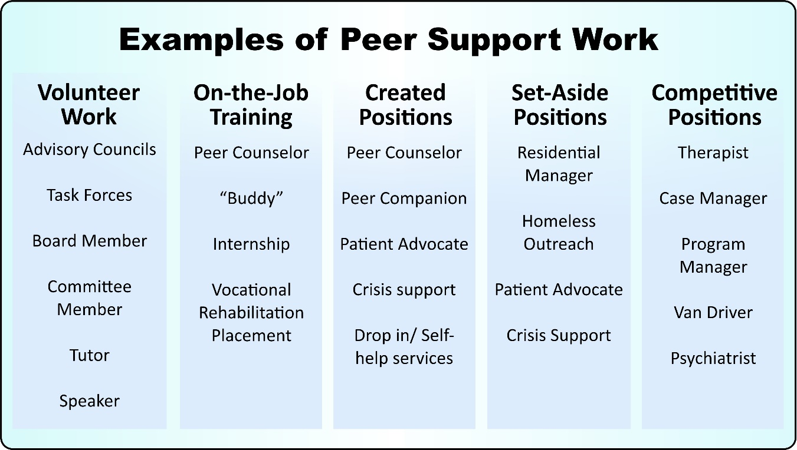
In a paper titled “From darkness to light: Barriers and facilitators to mental health recovery in the South African context”, De Wet and Pretorius, concluded that “recovery needs to be supported at an individual level, especially through an under-utilised resource such as peer support work, but in conjunction with the development of recovery-enabling environments in services and communities”. Peer Support Workers can be particularly valuable in providing support services in community-based settings where a continuum of care sets the foundation for recovery.
At a systems level, Peer Support Work can add immense value in settings where human resources constraints exist, especially in low and middle-income countries and which impact on the provision of effective and quality mental health care and services. Peer Support Work, if integrated within mental health systems, would be a perfect solution to help close the human resources gap.
Peer Support Work that is built into the mental health care system and at a community level makes economic sense when individuals receiving peer support services may be in a far better position to be empowered to take charge of their own mental health and overall health, and needing less from the specialized mental health care level, such as hospitalization (which is far more costly).
The COVID-19 pandemic that spread rapidly across the globe in 2020, has resulted in a significant impact on populations’ mental health and is expected to have serious mental health consequences post-COVID. Given this, the demand for mental health related interventions may increase as a result. To minimize the long-term impact of COVID-19 on population’s mental health and preventing unnecessary suffering from mental health problems, drastic attention should be given to recovery orientated services and programs in mental health. Peer Support Work can prove to be of particular value in these circumstances and support an already overstretched health care systems that are focused on the medical aspects of the pandemic. Building peer support services into the mental health care system now, will put countries in a better situation to deal with the mental health impact of future potential humanitarian crises or pandemics, such as COVID-19.
Note how the list of recovery-based practices this section began with can falsely give the impression that recovery-based practices are only suitable to working with people whose illnesses are stable or who are self-directed, but recovery principles can be applied to everyone. Remember that one of the three roots of the recovery movements was engaging challenging people without coercion. The challenges of both medical model and recovery model services are the same. We can both work with people at any stage of illness or recovery, but truly integrating person-centered, client-driven, and strengths-based values lead to very different practices.
Here are some examples of how to replace medical model services with transformed recovery model services:
 | Medical Model  (illness-centered, professionally driven,  deficit-based) | Recovery Model  (person-centered,  client-driven,  strengths-based)
Public Health | Mental Health First Aid:  Teaches people to recognize early signs of mental illness, destigmatize, and promote professional treatment | Emotional CPR: Teaches empathic listening, and empowering relationships to help people build their own growth responses to emotional crisis
Individual Prevention | Pre-emptive antipsychotic medications for people with family history of schizophrenia, “ultra-high risk” | Headspace: enhances social skills, relationships, and personal emotional skills for youth
Early Intervention  “First break” | RAISE: Rapid medication stabilization, using hospitalizations if needed, psychoeducation into chronic nature of illness and patient role, early rehabilitation to rebuild functioning | Open Dialogue: Intensive work with natural social network to preserve relationship and roles while person deals with unusual experiences
Intensive Ongoing Support | ACT: “hospital without walls”, multidisciplinary, community-based team insuring medication treatment and life supports | Full Service Partnerships:  Multidisciplinary, community-based team including specialists that support a wide variety of people’s quality of life goals through collaborative, growth-oriented partnerships building increasing personal self-responsibility
Crisis Response | Police, urgent care, Psychiatric Emergency Rooms, involuntary hospitalizations designed to avoid risk of danger and control people usually with medications | Soteria model crisis residential, peer respite programs designed to give space for people to regain self-control and learning what changes to make to stop suffering
Recovery | Illness Management Recovery: Focusing on chronic illness management | Clubhouses: Focusing on building positive personal roles and relationships  Voice Hearers: Focused on accepting voices as real experiences with personal meaning and integrating them into a positive self-identity

The most common “positive” outcomes from illness-centered treatment are someone with repressed psychotic symptoms, but limited self-identity, roles, community integration, resilience, protective factors, leaving them dependent on medications, vulnerable to relapses under stress, and with poor long-term health outcomes. The most common “positive” outcomes from person-centered approaches are someone who may have to continue to deal with psychotic symptoms while rebuilding a self-identity, purpose, relationships, and roles, either with ongoing medications (like Elyn Saks and Fred Frese) or without ongoing medications (like Dan Fisher and Mark Vonnegut).
Many of the programs in the recovery model side of the previous table are not widely available or even widely known. There is not an active debate comparing the two approaches. Here’s a brief description of the recovery programs listed above to assist in such a debate:
Emotional CPR: Rather than teaching the public how to identify warning signs of mental illnesses and refer people to professionals for help, Boston’s National Empowerment Center eCPR program teaches the general populations how to help each other through emotional crisis, building listening and emotional presence skills based on work done with trauma-informed care, counseling after disasters, and peer-support, to help Connect, emPower, and Revitalize people to grow from their crisis.
Headspace: A widespread one-stop shop program in Australia, often located in shopping malls or virtually with eheadspace, especially geared for young people ages 12-25 to help them develop mental and social connection skills to help get them back on track and strengthen their ability to manage their mental health in the future. Services are designed, developed, and evaluated by young people ranging from early psychosis interventions to educational and employment support.
Open Dialogue: Beginning 30 years in rural Finland, instead of removing people from their connections when someone has a psychiatric crisis, hospitalizing and forcibly medicating them, they send staff with family therapy expertise into people’s homes to convene groups of everyone who cares about the person, called “open dialogues,” week after week, to help them stay in their community. According to their published outcomes, 80% of people with “first-break” psychosis have recovered and are off medications within 6 months, including many who never required antipsychotic medications.
Full Service Partnerships: In California the traditional ACT team programs have evolved to integrate specialty, quality-of-life services beyond psychiatric services including financial, family support, housing, vocational, educational, substance abuse, physical health, and community integration. Instead of using a paternalistic professionally driven approach, these FSP programs create client-driven, collaborative partnerships working on the client’s life goals. Clients of all age ranges (children, transitional age youth, adult, and older adult) with severe disruption (homelessness, jailing, multiple psychiatric hospitalizations) are actively recruited and engaged and then supported to grow and move onwards to more self-responsible levels of care.
Soteria model crisis homes: Based on experiences guiding people on LSD trips, the personal growth path was tried at a short-term crisis residential program for people with psychosis called Soteria in northern California between 1971 and 1983. It was used as an alternative to hospitalizations and medications. Six or seven people lived there at a time or an average of 4 to 5 months. While only medicating 3% of residents, the outcomes both in terms of 6-week symptom reduction and 2-year recovery rates were as good or better than the outcomes for people hospitalized and medicated. The staff were non-mental health professionals chosen for their ability to relate warmly and intensively to residents “meeting them where they were at” without fearing or pathologizing them. They focused on helping them make sense of what they were going through.
Clubhouses: Beginning with Fountain House in New York, clubhouses are places for people with mental illness to take on roles apart form their conditions, built on their strengths and interests. Clubhouses are places of belonging as “members” of the club. They are partly or entirely member-run. Instead of identifying people by their conditions (e.g. “He’s in the schizophrenia early intervention program” or “She’s a battered woman and rape survivor”) people are identified by their positive, contributing roles that are essential to the running of the clubhouse (e.g. “He’s our greeter and cook”. “She’s our publicist and teacher of our art class.”).
Voice Hearers: The “Hearing Voices” movement and network emerged over the last decade from the Netherlands and the United Kingdom spreading to 26 countries at this point. It supports people who hear voices to avoid a pathological schizophrenic identity, instead normalizing hearing voices and helping each person through self-help groups, conferences, and websites to find meaning in their voices and strength in their ability to cope with and learn from their voices. Eleanor Longden’s 2013 TED talk, “The Voices in My Head,” dramatically describes this approach in her own recovery.
Focusing on Psychiatric Hospitals:
Often in low and middle income countries, people with mental illness who experience a crisis, often have limited options available as an alternative to hospitalization and/or medication. These countries often tend to focus primarily on the biomedical model of care, introducing hospitalization and pharmacological intervention when a crisis occurs. To some degree is psychotherapy an option or an addition to the care package, but not much of community-based programs and support especially as a basis for crisis intervention and aiding a recovery process. In an ideal world, the community should be the primary environment that is adequately resourced to provide support, empowerment and crisis interventions. Hospitalization should be an absolute last resort, while continued support and services that focus on empowerment are available as, when and how a person needs it.
Hospitalization based on its environment in specific can be either a positive or negative experience in the context of recovery. Two aspects are important in the case of inpatient care and may have much baring on the outcome of care received; the physical and attitudinal environments – both are important to instill dignity and to create a space that is conducive for recovery to take place.
The history of psychiatry and related to asylums, and despite the movement towards deinstitutionalization over the past decades, we still find psychiatric hospitals that present with the same visual appearance as asylums – associating psychiatric hospitals as prison-like facilities that create fear and a sense of punishment. In such conditions, recovery is not possible. The physical aspect or the built environment which has been poorly maintained has been associated with greater psychological distress. The NSW Ministry of Health noted that patients indicated that a “well-maintained, well-designed inpatient unit with a comforting feel” can contribute to personal recovery.
Negative attitudes within the healthcare system towards persons with mental illness may create resistance to access mental health care and services of any kind, and so impact on recovery. Cultural differences and the model of care of a healthcare system, as well as the educational level of a person with a mental illness, can have an impact on how such a person is perceived by a healthcare professional and how the attitude towards them will manifest.
There has been much focus on reducing stigma among healthcare professionals over the past decades with a greater recognition generated towards involving persons with lived experience with mental illness in the education of healthcare professionals as a potentially effective strategy to improve the attitudes towards their clients.
It is only when both physical and attitudinal adjustments are aligned with an environment that is safe, comforting, dignified, helpful and hopeful, and where human rights form the foundation for care, will recovery be promoted in psychiatric hospitals or other inpatient care facilities. With this being said, the importance of positive physical and attitudinal environments must always apply to any space where mental health care and services are provided, not only inpatient care settings.
Mental health crisis intervention often involves the police – for example in South Africa, when a person is regarded as a potential ‘danger’ to him/herself or to others and refuse treatment, an involuntary admission process is activated where the police, under Section 40 of the Mental Health Care Act of 2002, are called upon to assist in transporting such a person to a general hospital with a psychiatric ward, for assessment and possible [involuntary] admission. The involvement of the police in such crisis situations may exacerbate stigma, criminalize mental illness and in some instances there has been reports of excessive force used by police that has resulted in harm and even death. Needless to say, this experience can cause trauma and hinder recovery. The Support Team Assistance Response (STAR) pilot program with a two-person team (a medic and a clinician) that has been implemented in Denver in the US, is a good example of an alternative to deploy the police in crisis situations.
A human rights framework is essential in recovery, and is an area that needs much rethinking and reframing to comply with international human rights instruments to ensure that services at any care level are not causing more harm than good. Involuntary treatment or any form of coercion in mental health have been heavily debated, criticized and condemned, and noted as failing to align with the United Nations Convention on the Rights of Persons with Disabilities. The United Nations Human Rights Council called upon States to “abandon all practices that fail to respect the rights, will and preferences of all persons, on an equal basis” with others and to “provide mental health services for persons with mental health conditions or psychosocial disabilities on the same basis as to those without disabilities, including on the basis of free and informed consent”.
Even in wealthy countries psychiatric hospitals control a considerable amount of funds compared to community services. This is largely due to the fear of dangerousness and lack of tolerance of “mentally ill behaviors” in the community. Psychiatric patients, although statistically no more dangerous than anyone else, continue to be locked up as “dangerous to self and others” usually brought to the hospital by police in handcuffs. When hospitals aren’t available they may be taken to jails instead. Hospitals are being used as “refugee detention centers” for people with mental illness. They are where people are taken when they’ve become so unbearable, either to themselves or the people around them, that they are forced to leave their homes, families, and communities. They’ve become refugees in their own communities.
If we move away from fear and intolerance-based priorities and move towards considerations of enhancing the personal experience while in crisis, helping people regain control of themselves, reducing further trauma and coercion, building on their strengths, helping them reconnect to others, and taking responsibility for their actions so the cycle of crisis can stop, a whole range of crisis alternatives appear:
- Police can be replaced by or supplemented with mental health staff in the community to de-escalate conflicts and mediate being able to remain in their homes and lives (e.g. “Memphis model Crisis Intervention Teams)
- Hospitals can be replaced by crisis residential programs (e.g. Progress Foundation).
- Soteria model programs help support people as they go through disturbing, potential dangerous, emotional experiences, to regain self-control and find meaning and growth in their crisis experience
- Trauma informed care can be used, including within locked hospitals to reduce the use of seclusion and restraints
- Peers can have a very active role either integrated within ER and hospital settings or running their own crisis residential programs (e.g. Recovery Innovations crisis stabilization centers and peer-operated “living room”)

Part 5: Recovery programs and systems of care:
People in many places are using recovery principles and practices, but rarely has it grown to entirely recovery-based programs or system of care, even though it’s possible. Recovery is still predominantly an “outsider” movement, struggling on the edges of our mental health systems, both wealthy and poor. This often translates to being starved of necessary funds:
The COVID-19 pandemic has directed much focus on mental health at high level structures. UN Secretary General António Guterres noted that “Mental health services are an essential part of all government responses to COVID-19. They must be expanded and fully funded”. Unfortunately, financial support has not been activated. Before COVID-19, governments in low- and middle-income countries were spending on average only 1.6% of health budgets on mental health. According to the World Health Organisation (WHO), by June to August of 2020, from 130 countries that participated in a survey, found that 89% of responding countries reported that Mental Health Psychosocial Support (MHPSS) is part of their national COVID-19 response plans, yet only 17% of these countries have ensured full additional funding for it.
Nonetheless, here’s what an integrated recovery-based mental health program looks like:

Values:  HOPE  GROWTH  RESPECT  SOCIAL INCLUSION | Practices:  ENAGEMENT  EMPOWERMENT  REHABILITATION  SHARED RESPONSIBILITY  TEACHING  PEER SUPPORT
Culture:  WELCOMING  HEALING  RECOVERY  COMMUNITY INTEGRATION | System design:  INDIVIDUALIZATION  INTEGRATED SERVCIES  FLOW PROMOTION  RELATIONSHIP BASED SERVCIES

For staff to practice most effectively, there needs to be an alignment between all four dimensions (values, practice, culture, and system design) and the alignment must carry up through the administration to the highest levels possible. Some tools are available to guide program and system leaders: Bill Anthony’s group at Boston University described how to apply four key recovery values (person orientation, person involvement, self-determination/ choice, and growth potential) to all practices. Mark Ragins and MHALA created the Recovery Culture Progress Report which assesses how much the program’s practices and structures reflect seven key recovery values: welcoming and accessibility, growth orientation, lived experience inclusion, emotionally healing relationships and environments, quality of life focus, community integration, and staff recovery (are staff begin treated the way we want them to treat the people they serve.) This tool has been used to assess program’s progress in embracing recovery and to make plans to move forwards.
Unfortunately, there are an array of forces commonly working against the growth and development of recovery-based services and systems. Wherever you go recovery-based practice will always be, to varying degrees, fighting against these norms:
- Fear driven
- Illness centered / reductionistic
- Dehumanizing
- Authoritarian / coercive
- Avoidant / rejecting
- Distancing / self-protective
- Stigmatizing / stereotyping
- Generalized / efficient /data driven
- Deficit based / risk aversive
- Protective / caretaking / care giving / sympathetic
- Cost conscious / system driven
- Secretive / shameful

Over the last 30 years, despite widespread proclamations and mission statements endorsing recovery, recovery has almost entirely grown through local efforts. The most successful recover-based efforts share these features:
- Sustained coordinated leadership
- Creating “learning cultures” in the programs
- Improving connections between programs and administration
- Including and hiring consumers
- Moving from a predominantly crisis response mode to a proactive, team based, planned mode
- Sufficient staff morale (vs. burnout)
- Program and staff and administration avoiding fear based action

Here are three examples, of many scattered around the world, of emerging, growing recovery-based programs and systems of care, each a product of its own unique community and culture, reflecting its strengths and resistances:
Singapore:
Singapore is a small, heavily populated island country. It is very pragmatic and materially successful. The government is very autocratic and, using the most talented people available, actively socially engineers the society with financial incentives and tight controls, creating a meritocracy working for the communal benefit of all. They are far more concerned with productivity and harmony than with individual emotional expression or psychological mindedness. Authorities, like medical and mental health professionals are expected to be obeyed. There is very tolerance for disruptive and destructive behaviors like substance abuse, overt mental symptoms and disability, and homelessness. Family responsibilities are incentivized and foundational to their multicultural society.
Given these cultural conditions, they embrace illness-oriented paradigms, authoritative professional direction, and began building their system with a large 2000 bed long term psychiatric hospital. This description is from a psychiatrist who has led recovery based system transformation in Singapore, Dr Joseph Leong, currently the President of the Association for Psychiatric Rehabilitation in Singapore:
“Just one year after graduation from medical school in 2000, I sought a posting at the Institute of Mental Health, Singapore (Woodbridge Hospital). This is the state mental hospital with a bed capacity of over 2000 beds. It has been a fruitful journey of learning, caring and sharing about recovery to whoever would listen.
As a young doctor, I was required to take care of the acute, long stay as well as out-patient clinics of the hospital. I saw disturbed, aggressive and violent behavior in the acute setting ; the quiet and quaint environment in the custodial long stay as well as persons in good recovery, working and making a living in the outpatient setting.

I was intrigued to see the big difference when patients are well and working. There were even patients who were labelled with treatment-resistant schizophrenia on clozapine and yet working and living a meaningful life. I sought to learn from these group of patients who made it. I asked these patients if they don't mind if I see them for the longer term as their "regular" doctor. Actually they are my "teachers" as there are not many publications on recovery. I found that many of them have a meaningful role and routine as a worker or even a care-giver. I made "special" arrangements so that they can fulfil their role - for the mothers who need to fetch their kids to and fro school, I ensured that their appointment slots do not clash with those timings when they need to be fetching their kids. For persons who are working and who are on depot injections. arrangements were made for them to come in the evening or weekends when they are not working for their depot injections.

I strongly believe in creating a welcoming space and learning from recovery stories - focusing on a person's strengths, interests and goals. This greatly engage the person to take steps towards wellness and recovery , one step as at a time.

I got myself certified as a psychiatric rehabilitation practioner and also did a 6 month fellowship with Prof Robert Paul Liberman in 2009, returning to Singapore with 8 psycho-social rehabilitation projects. I told Prof Bob that the Ministry of Health in Singapore might not support some of these projects as they don't come under healthcare and he wisely replied that if I have offered it to the hospital first, is there anything stopping me from offering to others outside the hospital.

The first project was a multi-discipline team psycho-social rehabilitation clinic with Occuputional Therapists and Case Managers who sit in the sessions to link patients to services as soon as interest was expressed. This helped OTs and CMs to learn first hand what psychiatrists do during medicine review.

The 2nd project was a weekly Personal Effectiveness for Successful Living (Social Skills Training Group) which ran from 2010-2013. At its peak, there were 5 such groups ran by OTs including a mixed Mandarin-English group. A poster was presented at the World Association for Psychiatric Rehabilitation Conference in Milan, Italy in 2012 and was awarded the Best Poster Award.

The 3rd project was to strengthen and systematised the Individual Placement & Support (IPS) model in our Job Club. This was done through staff training as well as redesigning of roles and routines of staff.

The 4th project was adopting and adapting the NAMI's Family-to-Family Training to the local context and localised the content. Caregiver Alliance was birthed in 2011 and from only 1 site at the Institute of Mental Health, it had spread island-wide to 7 locations, strategically located within various goverment hospitals so that caregiverss can receive both support and training when their loved ones are hospitalised or when they come for their consultations. This work was recognised both nationally, regionally and internationally and caregivers' stories of resilence are now celebrated every year at the Singapore Caregiver Awards and incorporate in the healthcare road map of Singapore.

The 5th project was the culturally attuned www.ClubHEAL.org.sg serving the Malay Muslim community by starting it within mosques and then multiple community sites after gaining credibility and competent staff.

The 6th project was inviting Dr Mark Ragins to Singapore to introduce Milestones of Recovery Rating Scale which is now widely used at the various Care Centers of Singapore Anglican Community Services as well as by the Community Mental Health Teams at IMH.

The 7th project was the Peer Support Specialists PSS / Worker Training over the last 10 years which now have PSS working in various community mental health settings.

The 8th project is the transformation of the Long Stay Custodial Wards of IMH rebranding to Recovery Care over the last 3 years and on-going initiatives to transform IMH towards more and more recovery-orientated culture.

What has really impacted me are the long-term friendships I have made with staff, caregivers as well as persons in recovery. Many of them now have a direct line to me. We have also multiple Wellness Groups on Whatsapp and Facebook page with many more writing and sharing their recovery stories via social media, the internet as well as traditional media.

I personally believe that Recovery is both an individual journey that all of us can take and also a movement together where many more will find meaningful relationships with family, friends, co-workers, hobbit groups and spirituality groups.”

The system they built in Singapore is built upon the existing pervasive social value of social inclusion instead of fighting against the illness-centered and professionally-driven pervasive social values. This chart describes the system they have created in terms of social inclusion, while incorporating common recovery practices including peer support:

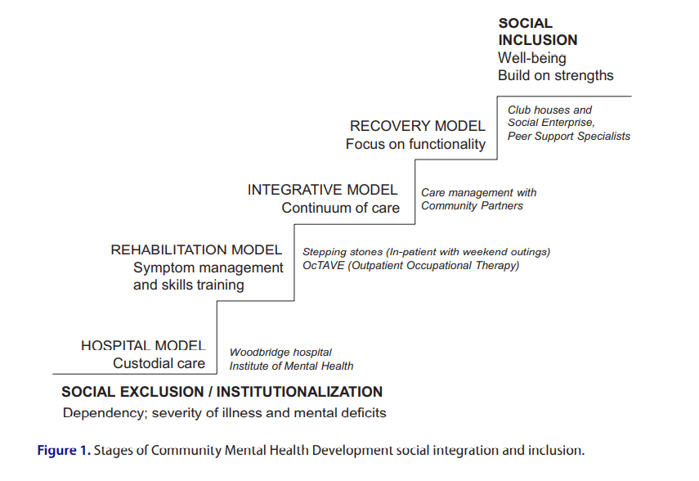
Czech Republic:
The Czech Republic is a small country that has been surrounded by and oppressed by its larger, more powerful neighbors including the Austro-Hungarian Empire, the Nazis, and most recently the Soviet communists. Yet it prides itself on its underlying cultural and intellectual tolerance perhaps exemplified by the tolerant, artistic reign of Emperor Rudolph II who was suspected of having serious mental illness, the famous Franz Kafka’s stories of imaginative, if not psychotic worlds, and having a playwright as their first independent president. Much of its mental health system is institutionally based persisting from the repressive communist era. Ledovec has been growing for 20 years in Pilsen, under the dedicated personal leadership of Martin Fojticek. Notice how he moves from the ideal of sharing his home with the people he’s helping to creating separate spaces but not emotional distance, not because of fear of violence even to his small children, but to preserve a healthy life-work balance to have a strong marriage and family too.

What Ledovec is and what it does:

“Twenty years ago my wife and I started our project Ledovec (meaning Iceberg in Czech, with the subtitle “most of it you can´t see”). We planned to set up a house where our family would live together with three or four other people with any kind of disadvantage, as we had experienced during our gap year in UK at Camphill Community Delrow House.

We rented an old parish house near Pilsen (the town where Pilsner beer was born) and set up an NGO. Since the house was not in good condition, we decided to start with “a day program” for anyone in need, mostly for people with learning difficulties or mental health challenges.
Looking back at this period of our life it helped me to describe this important “statistical paradox” (my wife and I are both graduated in mathematical statistics): in UK we met many families that sacrificed themselves to the community life, finished in divorce, their kids had serious behavioral problem etc. The same time we met only few families we admired, loved, we wanted to be like them. From statistical point of view the probability that our project turns up bad for us was much higher that other way round. Despite of it we started it. We trusted that this was our path, it made sense to us, even if we knew there was certain risk included. Today we know that hope and meaning make us to do things against probability. It is not rational. But it is right.

From Monday to Friday from the morning until the afternoon we were together, caring for the house, for our garden and later also for our goats, sheep and chickens. Together we cooked and ate, we baked our own bread, made goats cheese, even brewed out own beer. We organized public events, concerts, craft festivals, fairs. We welcomed volunteers (often from abroad), students, trainees and family members also. We had a rule: “when we sit round the table at lunchtime visitors should not recognize, who is paid and who pays for it”).

We wanted them to make further steps – to work, to anywhere else, not to be isolated with only one group of friends. We were not able to find anything suitable for our Ledovec people, they had not been accepted in other services, and they were fired from jobs they started. We decided to help them ourselves by moving our services into the community. With kind support from EU funds we opened our Supported Employment Agency in 2004, the first one in our region. We served not only our “day program” clients, but anyone who was interested in choosing, getting and keeping a job. For the next ten years we helped to about 60 or 70 people every year to succeed at labor market. Later we even founded (and helped others to found) several social entrepreneurship community businesses with more than 100 sheltered workplaces in our region.

To help us to survive as a family, we moved our services in 2005 to a separate Counseling Center in the Pilsen proper “protecting” our house from permanent visitors and potential clients and their families asking for support. We had two babies and we had to protect us as a family. In our Counselling Center we started a supported education project to support students with mental health disturbances and in 2006 we opened first sheltered apartments for people with severe mental health problems in Pilsen. We dropped the idea of shared household (at least for a while).

Today we run three community based multidisciplinary teams for people with severe mental illness which cover area of 300 000 inhabitants, a crisis phone line (3000 call a year), a counselling service, a team for sheltered living with 20 beds in 5 flats, a housing-first team and an early intervention team, as well as an educational agency and a clubhouse. We provide long term support to about 250 clients and short term intervention to hundreds of clients a year. We are involved in destigmatization campaigns, we continue in organizing public events, we participate in transformation of mental health system projects in our country. We support our clients to raise their voice and create opportunities in the community where they are heard.

Since very beginning of Ledovec we use the principle of so called “mutual social rehabilitation”. It means that we do not think that it is only our clients who has to change to fit better into the community, but also the community must change itself to be more open to all unique personalities in it.

Our special project is Cirkus Paciento– social circus we do together with patients and staff in mental hospitals. At the beginning of our four days stay in mental hospital no one there believes that they would participate in such a strange thing like circus performance, especially when they are seriously ill or terribly busy with all the job duties. We love the process when people slowly get engaged or sometimes even excited, show incredible capacity and skills, surprise fellow patients and staff and reap the applause at the end of the performance.

Recovery at Ledovec:

The first time I heard about recovery was in the Netherlands in 2007. We travelled there to see their supported education services. One colleague in Rotterdam gave us a copy of English article about recovery. I read it, it was interesting but that was it. Nothing special happened. Later one winter evening in 2011 I typed “recovery” in my Internet browser. Articles that Google found were marvelous! Ï read through one after another. And I fell in love with recovery.

We decided to spread recovery at home. At the beginning we translated some of the articles to Czech. Then we prepared a seminar on recovery and we presented it around the country. In 2016 we held 1st Czech International Conference on Recovery (with 200 participants including international speakers). We wanted to get in touch with more people who share the same passion, who can inspire us as they are ahead.

At about the same time we decided to do the “s.r.o. transformation” of Ledovec. Abbreviation s.r.o. in Czech means the same as Ltd. or Inc. Ledovec is a NGO, not limited company. By our transformation to s.r.o. we meant transformation of our services to “services recovery oriented”. Our recovery transformation altered our services and changed us as professionals.

Transforming our services was catalyzed in 2015 when we were happy to get very special project funded (by grant from Norway): We were paid to close down some of our activities we provided to our clients and instead find ways to support other organizations to offer those activities for the people we served in public spaces. The same people who were refused by agencies and our community when we began, now could be included in public spaces. We closed down some of our therapeutic workshops (those that existed in the community for the public) – candle workshop and weavery, we canceled our courses of yoga, IT skills courses, English and German lessons, sport group, bibliotherapy group and Board Games Club we organized. Instead, we contacted other providers and we encouraged them to let our clients use their public courses or to open new special courses for them. All the organizations were public companies (state library, IT skills city school, private language and sport schools). We did not want our clients being “imprisoned” in the system of MH services. The same time we realized we were becoming more and more part of that system instead of providing support to leave it).

We also rented premises near our center and started a clubhouse, which clients were encouraged to visit either just for cup of coffee or for some activities. Club was open in the afternoons, ran by people with own experience with mental illness. Seminars, groups and workshops were provided and led by “experts by theory” and by “experts by experience”. Roads to Recovery, Creative writing, How spirituality can support my recovery, Self-help group, Family members group, Forum for Transformation of Czech MH system etc. were examples of regular meetings.

We were happy when our clients took over one of therapeutic groups led by professionals. We also appreciated very much when our clients had formed a committee and negotiated with us against closing down the weavery (they made us to run it for one more year). In 2019 people around our clubhouse set their own self-advocacy NGO and applied for independent funding.

Transforming us was catalyzed when the s.r.o. process helped us to accommodate peer colleagues in our staff teams. But our main goal was to change the mindset in our heads, to open us more towards recovery. Despite my being in love with recovery, recovery must not be compulsory ideology! It is an opportunity. We proclaimed that every team has the freedom to accept as much of recovery oriented principles as its members want. Our teams started to discuss different aspects of recovery-oriented approaches and they started to implement them. This process showed us how important our language is. We turned to be more aware of what and how we say things. In 2017 we organized an internal conference where we negotiate about company´s values and we started to elaborate our new mission statement. Our new mission statement was presented in 2019. It says Ledovec creates the environment for people with mental health challenges, which help them on their paths of recovery. Much longer new Values and Principles were introduced in 2020. The same year we organized 2nd Czech International Conference on Recovery with more than 400 participants.

Here we are now. We see it as a journey of empowerment: Even if we trusted clients in our house twenty years ago we were trying to discover life paths for them, often connected with our project. Today we are just ready to help when they are discovering their unique life paths individually anywhere they want.

All this is just the “tip of the Iceberg”. Since the beginning our motto is “most of it you can´t see”. We believe that this is the case especially with recovery.”

California:
California is the place in the US where deinstitutionalization was first promoted. It also had, because of weather, economic disparities, demographics, and extremely high housing costs, the largest homeless populations in the US. California is home to an extremely tolerant, diverse, progressive, but not a caretaking or social responsibility for others, liberalism. There are wide open opportunities, but a very limited safety net if you can’t make it. Like everything in America, money is power and payment systems shape the services system.
Mental Health America of Los Angeles (MHALA) got a contract from the California state legislature in 1989 to run a four-year demonstration project to model the best community mental health services could be in avoiding homelessness, jailing, and psychiatric hospitalization while promoting independent housing, education, and employment. The Village combined three elements into an integrated program:
- A “no fail” ACT team intensity outreach, engagement, and case management, that included psychiatric and psychotherapeutic professionals
- A psychosocial clubhouse with supported housing, education, money management, socialization, and employment services
- A “case rate” funding system responsible for providing or contracting for all services including hospitalization and institutional care, that was held accountable for quality-of-life outcomes connected to the goals listed above, instead of a fee-for-service “medical necessity” billing system
The two sets of services were integrated, rather than separated, under the culture of psychosocial rehabilitation rather than medical model. This focus prepared the Village to be one of the leaders in the emerging recovery movement in the US.
Early on the focus was on radically reducing hospitalizations and institutional care, by using a combination of community based crisis care, both professional and peer provided, usually at people’s homes or in rented hotel rooms to control costs and divert the money to community engagement and rehabilitation services (the staff would meet to decide if we could come up with any community plan that would cost less than the hospital day would cost). Focusing on accessibility, providing for basic needs, building protective factors, and avoiding isolation on an ongoing basis reduced the overall level of crisis over time too.
The most challenging people, in every negative outcome, including cost, were the people who were actively using serious drugs. We weren’t permitted to throw them out of the program and we had to pay for their crisis. That led us to proactively devote a lot of time and attention to them, using new harm reduction and motivational interviewing strategies, while focusing our staff hiring practices on hiring people who would connect to people actively using drugs in supportive, nonjudgmental ways.
An independent research evaluator compared the program favorably to usual services, noting both the diversion of funds and the best quality of life outcomes they’d seen (about 70% reduction in homelessness, jailing, and hospitalization, and 400% increase in employment). But the average cost, per person of the program was about three times what the system was spending.
However, the system had a sizeable group of “high-utilizers” that cost substantially more than the Village services and the Village was diverted to focus on serving just those high-cost people – who also did quite well, almost indistinguishable form the original, disabled but not uniformly high cost, group. This new group generally had very limited family supports and were largely poorly educated, traumatized in childhood, and very impoverished. Black people were highly overrepresented, while Asians were highly underrepresented, compared to the surrounding community.
Our success was so dramatic that it was replicated throughout the state for other homeless and high cost people who previously had been failing in our usual system. The replication efforts were also so successful that there was a statewide ballot proposition passed to tax income in excess of $1 million dollars a year at a 1% rate to fund these programs to supplement the usual system. The Mental Health Services Act began with about $750 million per year in 2004 and is now generating over $2 billion per year as California’s wealthy get wealthier.
As “members” of the Village program improved, they no longer needed such expensive, intense services, and they were using “slots” that new people needed. There needed to be a way to determine the level of care someone needed in this system and how to flow them onwards “graduating” from the program making room for new people.
We developed the Milestones of Recovery Scale (MORS) based on three “person-centered” dimensions:
- Risk (which is expected to decrease as someone recovers)
- Engagement with services (which is expected to initially increase as they collaborate in their own recoveries and then decrease as they use more personal self-help and natural, community supports instead of staff support)
- Skills and supports (which is expected to increase as someone recovers. How much their improvement is based on supports rather than skills may hold them back from deeper recovery and independence.)
The three dimensions interact to form a non-linear, individualized map of recovery as follows:
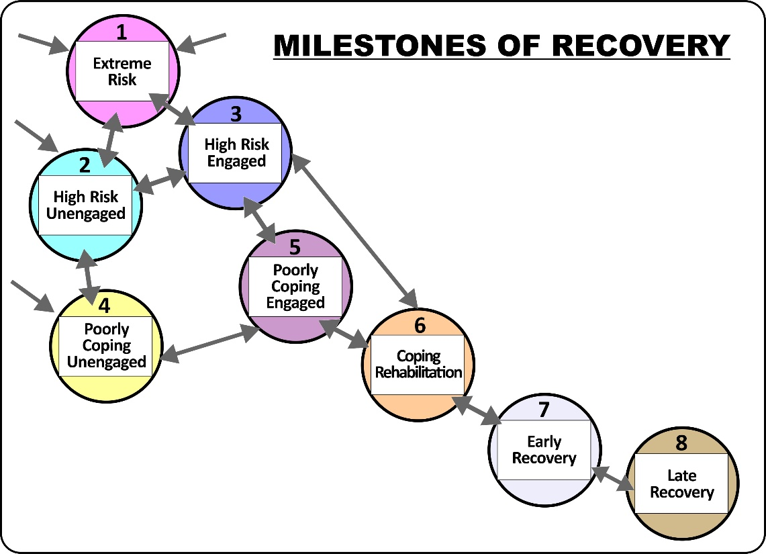
We could then determine the services someone needs (and indirectly their projected cost of services) by their MORS level. Here is a table of services using the MORS contrasting caretaking vs. growth-oriented services for each level:

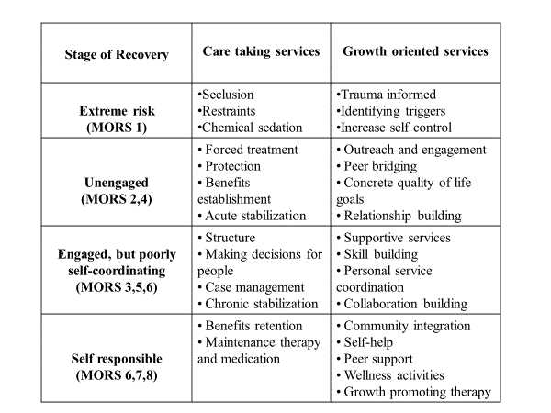
The Village began to create specialized teams and services for people at each level ranging from a Homeless Drop-in Center and a Welcoming Team for unengaged people, a Full Service Partnership (ACT level program for poorly self-coordinating people, and Village horizon Services and a Wellness Center for Self-responsible people. Members moved regularly as they followed through the program as they recovered (or sometimes unfortunately regressed backwards). Staff and members had to focus on both engagement and disengagement as people got help and support and then moved on, a more realistic model in contemporary, transitory America than “services of indefinite duration” the original ACT model.
Here’s a table that describes the entire system of care: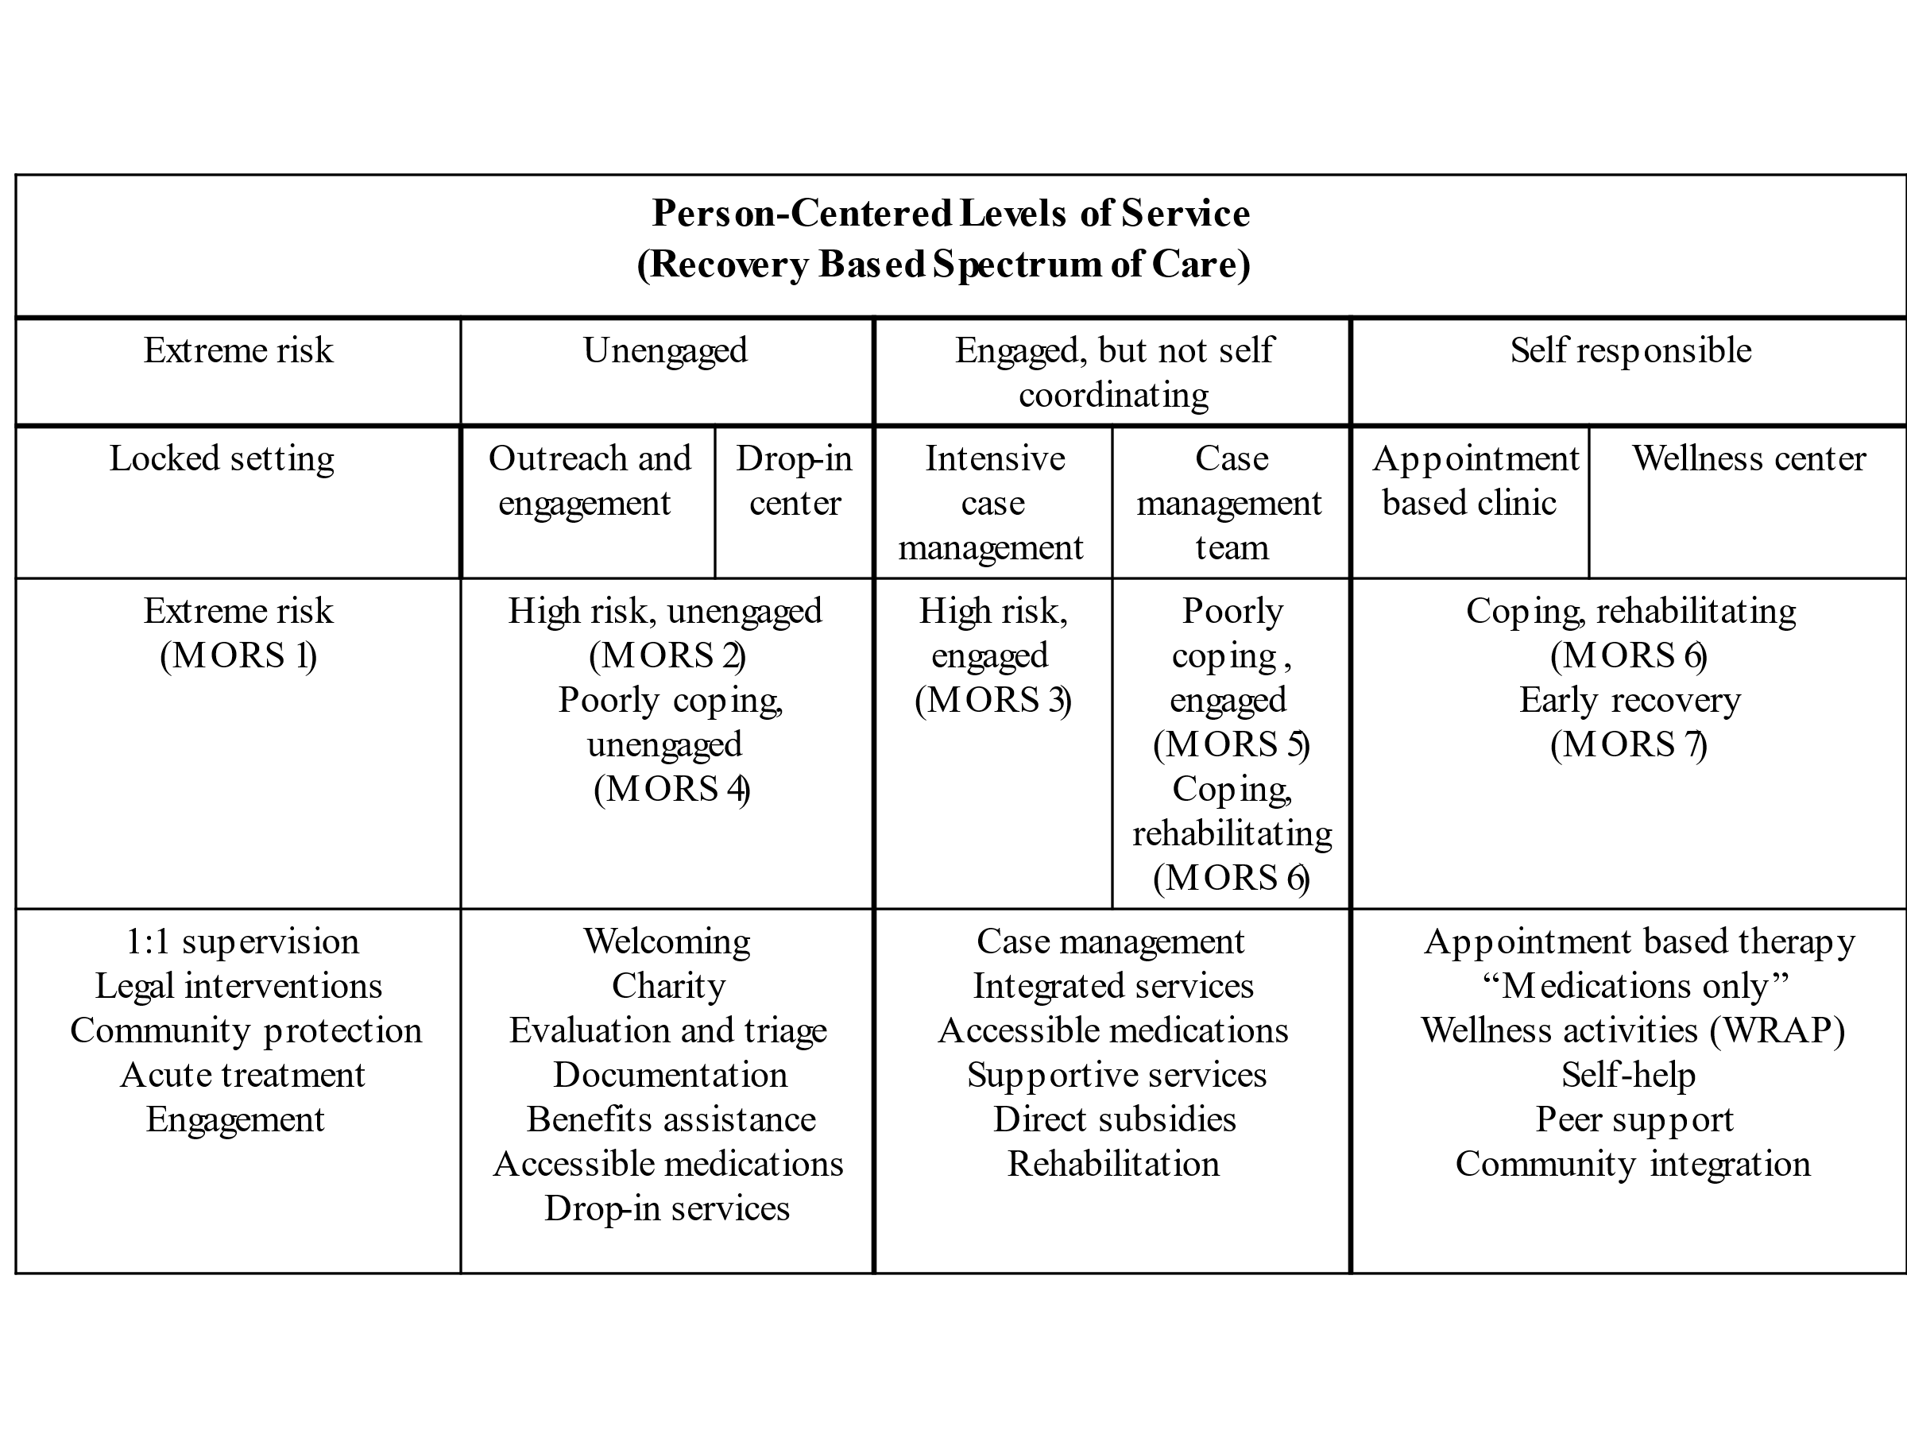Note that by this point we had succeeding in creating a recovery-based system of care that is more comprehensive than the usual medical model system of care, has very few people dropping out or falling between the cracks, and focuses on growth and recovery throughout, regardless of where someone is in the process or what their illness or symptoms are.
MHALA made considerable efforts to try to leverage its success into sustained system-wide transformation. These efforts have not been successful. Some of the interfering factors have been the Great Recession impoverishing our community and our system of care, gradual deterioration of the “case rate” payments, the county’s efforts to use our successful FSP programs to serve a variety of other people with serious social problems and costs including prisoners and jail diversion and medically fragile homeless people that require special expertise and additional funds that weren’t forthcoming, insufficient trained and motivated staff to work in this way, and perhaps most importantly, a failure to move the US federal public health insurances (Medicaid / Medicare) away from a fee-for-service medical model funding system leaving programs with funding auditors that conflicted with their recovery principles, relationships, services, and outcomes.
Inequalities and Funding:
Our three examples of developing a recovery-based system of care are all in developed, wealthy countries. Poor countries, where the majority of people live face additional challenges building any mental health system. That doesn’t mean they should stick within a medical model. Oftentimes, the recovery model, with its emphasis on peer support, quality-of -life services, building social support and social inclusion, can be more flexibly implemented than the medical model within low-income countries. But the challenges are striking,
On a social level, there exist huge inequalities between rich and poor, where the rich are able to access quality healthcare and in most countries financial wealth means to have better health and a longer life, while the poor are often subjected to ill health and premature death. Statistics indicate that poor communities are expected to die 20 or 30 years earlier than people from wealthy communities. Disparities across and between countries can be fairly significant, where these inequalities impact on the quality and efficacy of mental health services offered to those who seek treatment, and often associated with a lack of investment and outdated practices. In a study by Thornicroft and colleagues, conducted in 21 countries, it was found that 1 in 5 people with depression reported receiving minimally adequate treatment, from this figure was 1 in 27 in low-and-middle income countries. According the WHO, between 76 and 85 per cent of people with mental disorders in low-and-middle income countries receive no treatment, and between 35 and 50 per cent of those in high-income countries. Inequalities can create a number of barriers to recovery, from sustaining poverty, poor access to recovery orientated services and support, and ultimately poor quality of life.
There is an estimate shortfall in funding for mental health ranging from US$1.88 per person in low-income countries to US$2.62–3.70 per person (US$6,600–9,330 million in total) in lower middle-income countries. It is estimated that globally mental health receives between 1 to 4 per cent from health budgets. Unfortunately and despite the deinstitutionalisation movement that was intended to migrate people to communities for services and support, the money didn’t follow the ‘patient’ from hospital to the community. Needless to say, the vast majority of mental health budgets in low-and-middle income countries, are allocated to psychiatric hospitals, with little invested in the community towards recovery orientated services and support where it can yield far greater individual, social and economic benefits. Globally, joint efforts from mental health lived experience and advocacy movements have placed an emphasis on and called upon governments to reform its policies and financing structures to enable alignment of services and practices with human rights instruments and evidence. This movement acknowledges that greater investment is required to truly build mental health services and support that honours the principles of recovery.
Closing thoughts:
Narrative: Tivania (South Africa)
I had suffered with depression and anxiety for over 20 years, culminating in a failed suicide attempt in 2014. That was the greatest gift I was given: a second chance. A chance to choose life on my terms. Not everyone is that lucky.
I spent over 20 years of my life hiding under a bushel of shame. Shame that something was wrong with me. Shame for my life experiences and being a 'failure' by society's standards. Shame that I couldn't snap out of this pain that I carried with me. I was never given a voice and that silence made me sicker. My failed suicide attempt began my journey inward, the longest journey I'd ever taken, because we're seduced into suppressing our pain and negating our truth - whatever that may be. Through the gift of love and kindness, I was given permission to show up in this world as who I truly am and not what I was forced to be. My life has changed so dramatically since. I have become the kind of woman I always longed to be: empowered, unashamedly owning and speaking my truth, and living a life of purpose now as a published author, motivational speaker, social media influencer, empowerment activist and Executive Committee member of the GMHPN. I get to now share my story candidly and allow others the freedom to do the same, through love, awareness around mental health and hope for recovery.
We are the light-bringers in this world, and we can only see our light in the darkness. Therefore the darkness is not wrong, it is a gift. And now, we get to light up the path for others. Own that truth unashamedly. Through all the elements of recovery - hope, empowerment, inclusion, resilience, dignity and purpose in life, we as people with lived experience become enabled to drive change within ourselves and within the world.

The recovery movement is very ambitious. It seeks to take us beyond treating illness, to focusing on helping people have better lives, and regain important roles and acceptance within their communities…even for people whose symptoms can’t always be eliminated or controlled and even for people with very serious persistent conditions like schizophrenia. When we can create entire recovery programs and systems of care, that integrate transformed psychiatric services with engagement, trauma and substance abuse recovery and healing, peer support, rehabilitation, community integration, and so much more, rather than seeking just to use recovery as an add-on when funding allows, we will finally be able to seriously address the grievances and neglect of people with mental health lived experience, amplify and learn from their voices, and ultimately be able to see the vast majority of them recover.

Report cover letter, President's New Freedom Commission on Mental Health, July 22, 200
The New Zealand Mental Health Advocacy Coalition Destination Recovery 2008 The Mental Health Foundation of New Zealand
Deegan, Patricia PhD Coping With Voices: Self-Help Strategies for People who Hear Voices that are Distressing https://power2u.org/store/coping-with-voices-booklet/
Fisher, Daniel MD, PhD PACE, A Recovery Curriculum - National Empowerment Center (www.power2u.org)
Harding CM, Brooks GW, Ashikaga T, Strauss JS, Breier A: The Vermont longitudinal study of persons with severe mental illness, I: methodology, study sample, and overall status 32 years later. Am J Psychiatry 1987; 144:718–726
For example, Bleuler M: The Schizophrenic Disorders: Long-Term Patient and Family Studies (1972). London, Yale University Press, 1978
Liberman, M.D., Charles J. Wallace, Ph.D., Gayla Blackwell, R.N., M.S.W., Alex Kopelowicz, M.D., Jerome V. Vaccaro, M.D., and Jim Mintz, Ph.D. Skills Training Versus Psychosocial Occupational Therapy for Persons With Persistent Schizophrenia Published Online:1 Aug 1998https://doi.org/10.1176/ajp.155.8.1087
Robert Paul Liberman, M.D. Recovery from Disability: Manuel Of Psychiatric Rehabilitation Jun 30, 2008
E. Sally Rogers, William A. Anthony, and Marianne Farkas The Choose–Get–Keep Model of Psychiatric Rehabilitation: A Synopsis of Recent Studies Boston University Rehabilitation Psychology 2006, Vol. 51, No. 3, 247–256
The Meaning and Importance of Employment to People in Recovery from Serious Mental Illness: Results of a Qualitative Study
World Health Organization. 2017 Mental Health Atlas. Geneva: World Health Organization, 2018
World Economic Forum - The Global Economic Burden of Non-Communicable Diseases.
Fountain House, New York City (November 1999). "Gold Award: The Wellspring of the Clubhouse Model for Social and Vocational Adjustment of Persons With Serious Mental Illness". Psychiatric Services. 50 (11): 1473–1476. doi:10.1176/ps.50.11.1473
Farrell, SP; Deeds, ES (January 1997). "The clubhouse model as exemplar. Merging psychiatric nursing and psychosocial rehabilitation". Journal of Psychosocial Nursing and Mental Health Services. 35 (1): 27–34. doi:10.3928/0279-3695-19970101-15
Howard A. Rusk, M.D. "Mental Rehabilitation; Fountain House on 47th St. Is Mecca To Many Former Patients in the State". The New York Times. February 4, 1968.
Larry Davidson, Michael Rowe, Janis Tondora, Maria J. O'Connell, Martha Staeheli Lawless A Practical Guide to Recovery-Oriented Practice: Tools for Transforming Mental Health Care 2008
World Health Organization, User empowerment in mental health: A statement by the WHO regional office for Europe. 2010, World Health Organization: Copenhagen: Denmark.
World Health Organization. An overview of a strategy to improve the mental health of underserved populations. Geneva: WHO; 1999. https://www.who.int/mental_health/media/en/46.pdf.
Corrigan PW, Watson AC. Understanding the impact of stigma on people with mental illness. World Psychiatry. 2002;1(1):16-20
Thornicroft, G., Brohan, E., Kassam, A., & Lewis-Holmes, E. (2008). Reducing stigma and discrimination: Candidate interventions. International Journal of Mental Health Systems, 2, Article ID 3. http://dx.doi.org/10.1186/1752-4458-2-3
Ragins, Mark MD A Road to Recovery 2002
Alcoholics Anonymous : Twelve Steps and Twelve Traditions (aa.org) https://www.aa.org/pages/en_US/twelve-steps-and-twelve-traditions
For example, Bessel van der Kolk The Body Keeps the Score: Brain, Mind, and Body in the Healing of Trauma 2014
Ragins, Mark MD Person Centered vs Illness Centered 2006
Sunkel, C. Global Burden of Mental Illness
Brooks, C (2018) pro bono research conducted for the World Dignity Project and presented at the Universal Health Mental Health for all Congress, December 2018.
William R. Miller, Stephen Rollnick Motivational Interviewing: Preparing People for Change 1991
Deegan, Patricia PhD Common Ground Guides https://patdeegan.myshopify.com/collections/commonground-guides
Copeland, Mary Ellen PhD Wellness Recovery Action Plans https://mentalhealthrecovery.com/
Larry Davidson, Ph.D. Maria O’Connell, Ph.D. Janis Tondora, Psy.D. Thomas Styron, Ph.D. Karen Kangas, Ed.D. The Top Ten Concerns About Recovery Encountered in Mental Health System Transformation PSYCHIATRIC SERVICES ps.psychiatryonline.org May 2006 Vol. 57 No. 5
Ragins, Mark MD Taking Strengths Seriously 2011
Substance Abuse and Mental Health Services Administration SAMHSA’s Working Definition of Recovery Publication ID: PEP12-RECDEF (brochure) Feb 2012
Jacob KS. Recovery model of mental illness: a complementary approach to psychiatric care. Indian J Psychol Med. 2015;37(2):117-119. doi:10.4103/0253-7176.155605
Sunkel, C. Global Burden of Mental Illness
Ragins, Mark MD Journeys Beyond the Frontier: A Rebellious Guide to Psychosis and Other Extraordinary Experiences 2021
Pitt V, Lowe D, Hill S, et al. Consumer-providers of care for adult clients of statutory mental health services. Cochrane Database Syst Rev 2013;3:CD004807.
Puschner B. Peer support and global mental health. Epidemiol Psychiatr Sci 2018;27:413–4.
De Wet A, Pretorius C. From darkness to light: Barriers and facilitators to mental health recovery in the South African context. International Journal of Social Psychiatry. December 2020. doi:10.1177/0020764020981126
Mental Health Gap Action Programme. mhGAP Intervention Guide for mental, neurological and substance use disorders in non-specialized health settings, Version 2.0. Geneva: World Health Organization; 2016.
National Council for Behavioral Health. www.mentalhealthfirstaid.org
Emotional CPR. www.emotional-cpr.org
Yung A, Nelson B. The ultra-high risk concept – a review. Canadian J Psych. 2013; 58 (1) 5-12.
Headspace National Youth Mental Health Foundation Ltd. www.headspace.org.au
Dixon LB, Goldman HH, Srihari VH et al. Transforming the treatment of schizophrenia in the United States: the RAISE Initiative. Annual Review of Clinical Psychology. 2018; 14:237-258.
The Institute for Dialogic Practice. www.dialogicpractice.net/open-dialogue/about-open-dialogue/
Dixon L. Assertive community treatment: twenty-five years of gold. Psychiatric Services. 2000; 51: 759-765.
California Institute for Behavioral Health Solutions. Full Service Partnership Toolkit www.cibhs.org/publication/fsp-toolkits#:~:text=Full%20Service%20Partnership%20%28FSP%29%20programs%20were%20designed%20under,and%20their%20family%20members%2C%20mental%20health%20service%20providers.
Calton T, Ferriter M, Huband N, et al. A systematic review of the Soteria paradigm for the treatment of people diagnosed with schizophrenia. Schizophrenia Bulletin. 2008; 34 (1): 181–92
Substance Abuse and Mental Health Services Administration Illness Management and Recovery: Practitioners Guides and Handouts SMA-09-4462 2009
McKay C, Nugent KL, Johnsen M, et al. A systematic review of evidence for the clubhouse model of psychosocial rehabilitation. Administration and Policy in Mental Health and Mental Health Services Research. 2018; 45 (1): 28–47.
Hearing Voices Network https://www.hearing-voices.org/
Evans G. The Built Environment and Mental Health. Journal of Urban Health: Bulletin of the New York Academy of Medicine. 2003;80(4):536-555. doi:10.1093/jurban/jtg063
NSW Ministry of Health. (2018). Preventing Seclusion and Restraint: Mental Health Safety and Quality in NSW Built and Therapeutic Environments. https://www.health.nsw.gov.au/mentalhealth/reviews/seclusionprevention/Factsheets/built-therapeutic-environment.pdf
N. Des Courtis, C. Lauber, C. T. Costa, and K. Cattapan-Ludewig, “Beliefs about the mentally ill: A comparative study between healthcare professionals in Brazil and in Switzerland,” International Review of Psychiatry, vol. 20, no. 6, pp. 503–509, 2008.
H. F. Mirnezami, L. Jacobsson, and A. Edin-Liljegren, “Changes in attitudes towards mental disorders and psychiatric treatment 1976-2014 in a Swedish population,” Nordic Journal of Psychiatry, vol. 70, no. 1, pp. 38–44, 2016.
O’Reilly C.L., Bell J.S., Chen T.F. Consumer-led mental health education for pharmacy students. Am. J. Pharm. Educ. 2010;74:167. doi: 10.5688/aj7409167.
Happell B., Byrne L., McAllister M., Lampshire D., Roper C., Gaskin C.J., Martin G., Wynaden D., McKenna B., Lakeman R. Consumer involvement in the tertiary-level education of mental health professionals: A systematic review. Int. J. Ment. Health Nurs. 2014;23:3–16. doi: 10.1111/inm.12021.
Grace Hauck. USA Today. Denver successfully sent mental health professionals, not police, to hundreds of calls. https://www.usatoday.com/story/news/nation/2021/02/06/denver-sent-mental-health-help-not-police-hundreds-calls/4421364001/
United Nations. Convention of the Rights of Persons with Disabilities: United Nations Human Rights, Office of the High Commissioner for Human Rights, United Nations, 2006.
United Nations Human Rights Council, Resolution on Mental Health and Human Rights, UN Doc A/HRC/36/L.25 (2017)
CIT CENTER A Resource for CIT Programs Across the Nation http://cit.memphis.edu/aboutCIT.php#:~:text=The%20Memphis%20Crisis%20Intervention%20Team%20%28CIT%29%20is%20an,training%20for%20helping%20those%20individuals%20with%20mental%20illness .
Progress Foundation https://www.progressfoundation.org/
Recovery Innovations International services https://riinternational.com/services/
WHO. The impact of COVID-19 on mental, neurological and substance use services: results of a rapid assessment. 5 October 2020. https://www.who.int/publications/i/item/978924012455
Marianne Farkas, Sc.D., Cheryl Gagne, M.S., William Anthony, Ph.D., Judi Chamberlin Implementing Recovery Oriented Evidence Based Programs: Identifying the Critical Dimensions Community Mental Health Journal, Vol. 41, No. 2, April 2005
Ragins, Mark MD A Recovery Culture Progress Report 2009 https://www.cardinalinnovations.org/getmedia/11319634-0663-4FE1-8BBC-B9B4E9567F43/a-recovery-culture-progress-report.pdf
Bhing-Leet Tan, Zhongying Li, and Catherine Hui-Moi Tan Evaluation of a national supported employment programme for people with psychiatric conditions British Journal of Occupational Therapy 79(5) DOI: 10.1177/0308022615615891 January 2016
Caregivers alliance https://www.cal.org.sg/milestones-and-awards
Refocus on Recovery Sept 2019 https://vimeo.com/366263170
: Shih Ying Gun & Joseph Jern-Yi Leong (2016) Social inclusion: the Singapore story in community mental health development, psychiatric rehabilitation and recovery, Asia Pacific Journal of Social Work and Development, 26:2-3, 167-177, DOI:10.1080/02185385.2016.1218793
Ledovec s.r.o. https://www.zotaveni.cz/zotaveni-nazivo/download/17_ef2fd5b46509502a116935eb043c3524
Cirkus Paciento www.cirkuspaciento.cz
Does Recovery Have It’s Own Language? https://youtu.be/mesHHTfCDjU
Ragins, Mark MD An Overview of the Village (1990-2008)
Meisel JMcGowen MPatotzka DMadison KChandler D Evaluation of AB 3777 Client and Cost Outcomes, July 1990 Through March 1992. Sacramento, Calif California Dept of Mental Health1993
Pilon, David and Ragins, Mark Milestones of Recovery Scale 2006 http://www.acbhcs.org/providers/QI/docs/WRR/Milestones_of_Recovery_(Dave_Pilon).pdf
5 shocking facts about extreme global inequality and how to even it up | Oxfam International. Oxfam International. Available at: https://www.oxfam.org/en/5-shocking-facts-about-extreme-global-inequality-and-how-even-it. [Accessed 28 May 2020].
Thornicroft G, Chatterji S, Evans-Lacko S, Gruber M, Sampson N, Aguilar-Gaxiola S, et al. Undertreatment of people with major depressive disorder in 21 countries. Br JPsychiatry. 2017;210(2):119-124.
World Health Organization. Mental disorders fact sheet [online]. WHO; 2019 [cited 2019 Oct 28]. https://www.who.int/en/news-room/fact-sheets/detail/mental-disorders
Gilbert BJ, Patel V, Farmer PE, Lu C. Assessing development assistance for mental health in developing countries: 2007-2013. PLoS Med. 2015;12(6):e1001834.
Vigo DV, Kestel D, Pendakur K, Thoricroft G, Atun R. Disease burden and government spending on mental, neurological, and substance use disorders, and self-harm: cross-sectional, ecological study of health system response in the Americas. Lancet Public Health. 2019 Feb;4(2):e89-e96.
World Health Organization. Mental Health Atlas. Geneva: World Health Organization, 2017

