In 2021 I wrote a book primarily based upon my experiences at the Village. “Journeys Beyond the Frontier: A Rebellious Guide to Psychosis and Other Extraordinary Experiences”. I expected one of the main audiences for the book would be NAMI members. I wrote this blog for a NAMI newsletter to describe the book.

A Rebellious Guide to Psychosis
(2021) by Mark Ragins MD

I’m the kid who pestered my parents and teachers by always asking “why?”.
By the time I finished college, I was fascinated by psychosis, but I was struck that there were very few books to read and learn about it, and that the books there were talked about illnesses and dopamine and genetics and medications and deinstitutionalization and not much else. They never seemed to ask, let alone answer, “why?”: Why is that person psychotic when no one else in their family is? Why do people hear voices? Why can’t they tell they’re not real? Why are there so many varieties of experiences? Why can’t we understand what they’re talking about or help them more?
I had a lot of questions and no convincing answers. I headed off to medical school to become a psychiatrist.
I’ve since learned that there are good reasons we don’t know, or even usually ask these questions. We’re wearing blinders we’re not even aware we have:
- We believe that the content of psychosis is meaningless. There’s no point trying to understand what they’re experiencing. They’re incomprehensible.
- We believe that people with psychosis are frightening and dangerous and we need to be very wary and careful around them.
- We believe that we can’t connect with people with psychosis. We need to keep our distance and avoid feeding into their delusions or we might become part of their delusional world.
- We believe people with psychosis are hopeless. They can’t recover. The best we can hope for is them staying on their medications, stabilizing, and not hurting anyone.
Each of these beliefs has been ingrained for over a hundred years. All of them are false even though they’re sanctified by our medical model mental health establishment and our society. And all of them are crippling us. They are the main reasons we’ve made so little progress in helping people with psychosis.
Here’s my “rebellious compass” to guide our questioning:
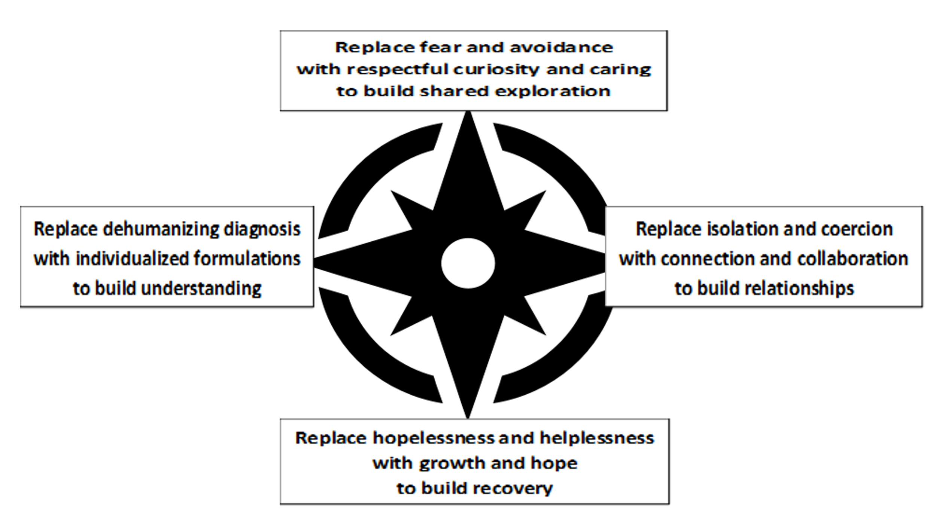
I’ve spent more than thirty years trying to be curious and caring, understanding, connecting, and spreading hope and recovery, most of it working at Mental Health America of Los Angeles’ Village in Long Beach California, one of the most successful mental health programs ever during its peak.
Somehow, I’ve become older along the way, though I’m not really sure when that happened, but it sure did, and in 2021 I decided to write the book that I wished I’d had when I was young, “Journeys Beyond the Frontier: A Rebellious Guide to Psychosis and Other Extraordinary Experiences.” It’s filled with true stories of people I’ve met, the explanations I’ve come up with for all my questions, and strategies to help people more effectively. (Buy it and tell your friends!! Here’s an amazon / kindle link: Journeys Beyond the Frontier: A Rebellious Guide to Psychosis and Other Extraordinary Experiences: Ragins, Mark: 9798714629495: Amazon.com: Books. )
I’ve learned that prolonged psychosis is not the product of a single, overwhelming illness we can call schizophrenia. It’s the result of many different pathways and causes, each of which should be approached, understood, and helped differently. My guidebook includes eight “journeys”:
1. Loss and grief
2. Psychotic reactions
3. Difficulties in making sense of the world
4. Childhood trauma
5. Losing balance
6. Drugs and alcohol
7. Psychiatric illnesses
8. Brain damage and other neurological and medical conditions

When is the last time you saw a mental health professional take the time to assess someone in all these areas to get to know why they’re experiencing psychosis?

If we’re going to take off our blinders and spend the time to go beyond superficial diagnoses, and really get to know people and how they got where they are, we’re going to need to use a 3-dimensional model not just a symptom checklist:
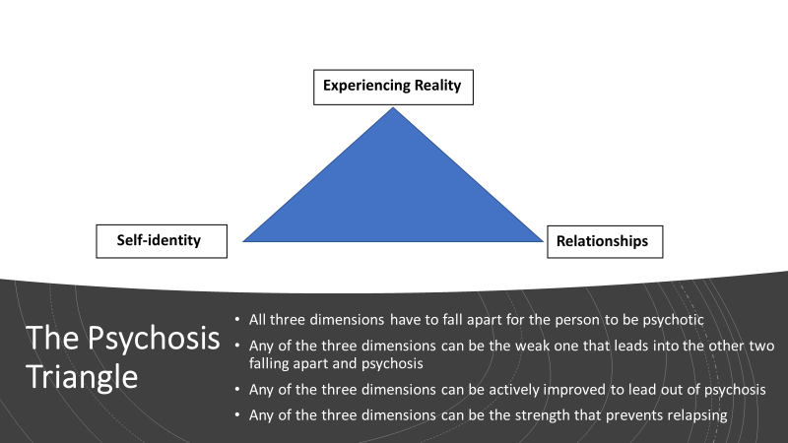

We need to demand the provision of, training in, and funding of, the most successful interventions and contexts across all three dimensions, rather than just the “medically necessary” services currently provided, trained in, and funded.
Here’s a brief list contrasting one-dimensional and three-dimensional interventions:
 | Medical Model  (Experiencing reality dimension only – often harms other dimensions) | Recovery Model  (includes self-identity and relationships dimensions)
Public Health | Mental Health First Aid and QPR | Emotional CPR
Individual Prevention | Pre-emptive antipsychotic medications | Headspace:
Early Intervention “First break” | RAISE | Open Dialogue
Intensive Ongoing Support | ACT teams | Full Service Partnerships
Crisis Response | Police, urgent care, Psychiatric Emergency Rooms, involuntary hospitalizations | Soteria model crisis residential, and peer respite programs:
Recovery | Illness Management Recovery | Clubhouses and Voice Hearers

Now that I know many ways that people get and stay psychotic and many ways to help them recover, and I even know why most people are wearing blinders and can’t see any of this, I’m left with one more question: Why can’t we remove our blinders and move forwards using what the rebels have learned?

